This survey is intended to gather feedback from learners following a virtual employer encounter event. It gathers learner perceptions on the organisation, engagement and impact of the event.

Remember, learner surveys about experiences are useful insights to inform your planning but are not sufficient in terms of a meaningful work experience, where learners should be given the opportunity to reflect on the experience, their learning and skill development.

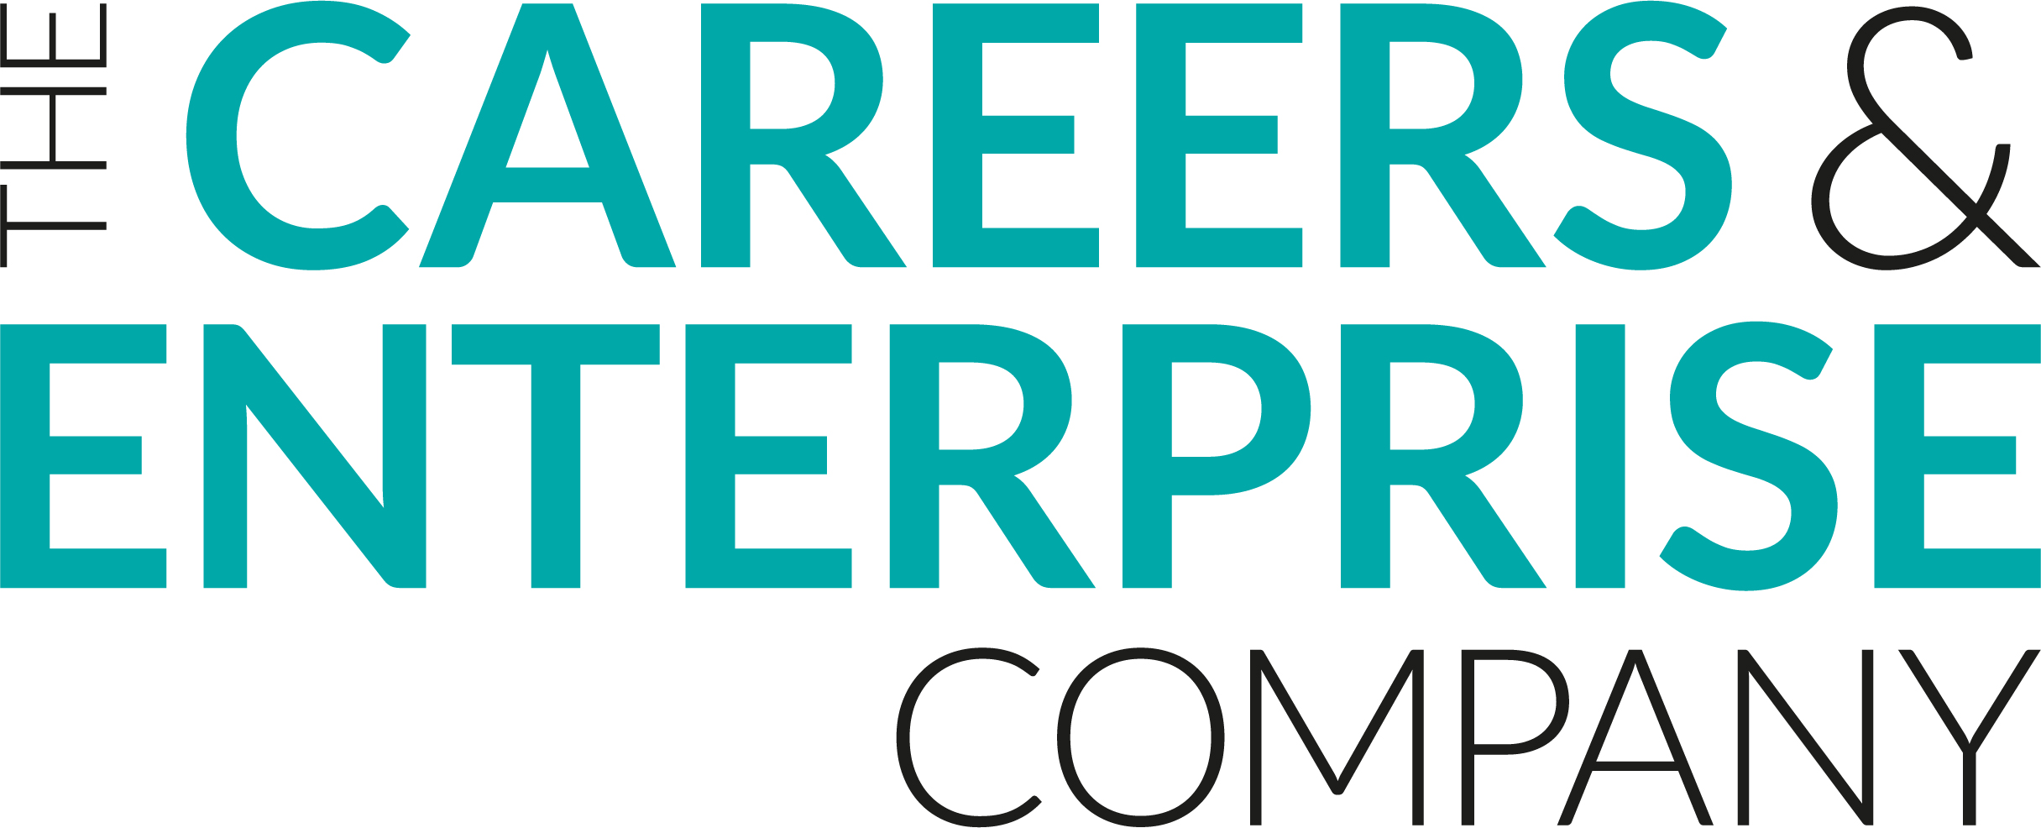
Meaningful Virtual Encounter Feedback
Learner
Learner Name:
Event Title:
Year Group/Key Stage:

- Did you feel supported to prepare for this event?
Yes, to a great extent | Yes, to some extent | Possibly, I’m not sure | No, not at all
- Did you understand the purpose of this event?
Yes, to a great extent | Yes, to some extent | Possibly, I’m not sure | No, not at all
- Did you enjoy this event?
Yes, to a great extent | Yes, to some extent | Possibly, I’m not sure | No, not at all
- Was the event relevant to your interests?
Yes, to a great extent | Yes, to some extent | Possibly, I’m not sure | No, not at all
- Did you feel that you could relate to the speaker?
Yes, to a great extent | Yes, to some extent | Possibly, I’m not sure | No, not at all
- Did you have the opportunity to ask questions?
Yes, to a great extent | Yes, to some extent | Possibly, I’m not sure | No, not at all
- Were you able to stay focused during the event?
Yes, to a great extent | Yes, to some extent | Possibly, I’m not sure | No, not at all
How much do you agree with the following statements:
- This event has helped me to understand something about careers and the world of work
Strongly agree | Agree | Neither Agree nor Disagree | Disagree | Strongly Disagree
- This event has helped me to understand something about the range of employment opportunities in my local area.
Strongly agree | Agree | Neither Agree nor Disagree | Disagree | Strongly Disagree
- The event improved my understanding of the knowledge and skills needed by employers
Strongly agree | Agree | Neither Agree nor Disagree | Disagree | Strongly Disagree
- The event helped me reflect on how my knowledge and skills match those needed by employers
Strongly agree | Agree | Neither Agree nor Disagree | Disagree | Strongly Disagree
- This event has helped me to develop essential skills (i.e. listening, speaking, problem solving, creativity, adapting, planning, leadership, teamwork)
Strongly agree | Agree | Neither Agree nor Disagree | Disagree | Strongly Disagree
- This event helped me think about what I might like to do once I finish school or college
Strongly agree | Agree | Neither Agree nor Disagree | Disagree | Strongly Disagree
- This event helped me feel increasingly confident and career ready.
Strongly agree | Agree | Neither Agree nor Disagree | Disagree | Strongly Disagree
- This event has changed my thinking about my future plans
Strongly agree | Agree | Neither Agree nor Disagree | Disagree | Strongly Disagree
- Are there any actions you intend to take as a result of this event?
- What went well about this event?
- How could this event be even better?

