Feeling prepared for careers conversations with parents
Here is a source of information to help you feel confident to have conversations with parents and carers about pathways, and that you can signpost families to, when having careers conversations.

Talking Futures website for parents and carers
Designed specifically for parents, this Talking Futures website hosts information, video content and activity ideas to help families have well informed careers conversations.

Pathways Posters
Compare your options after GCSEs - Your child's options
Use these posters to support parents in understanding options for their children
- For young people with SEND who are typically not likely to take GCSEs
- For young people with SEND who are typically likely to take GCSEs

Pathway options
There are three types of routes students can consider:
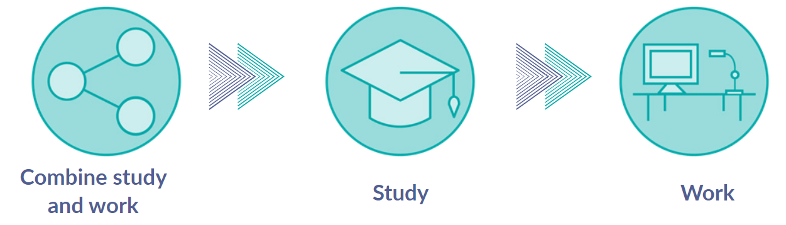

Talking Futures – explore education and training choices


Apprenticeships
Key information:
Apprenticeships are real jobs that allow young people to earn a wage whilst they learn. They can take 1 to 5 years to complete depending on the level and go all the way to degree level. Students can apply for an apprenticeship whilst still in school but must be 16 or over to start one.
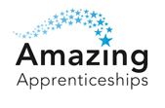
Amazing Apprenticeships Parent Zone

T Levels
Key information:
A T Level is a nationally recognised qualification for 16-19 year olds that lasts for two years and is the equivalent of 3 A Levels. Leading businesses and employers have helped design T Levels to give young people the knowledge and skills they need for work or further study.
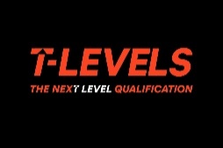
- This guide will support understanding of what T Levels are.
- Access this toolkit to develop your skills, knowledge and confidence in talking about T-Levels with parents
    - This site, T-Level info for parents, is aimed at helping parents understand T-Levels.
Vocational Technical Qualifications (VTQs)
Key information:
VTQs are practical qualifications for over 16s designed to help students get the skills they need to start their career or go on to higher levels of education. There are a few different types and levels of VTQs including BTECs from Levels 1 - 7, Cambridge Nationals: Levels 1 and 2, Cambridge Technicals: Levels 2 and 3 and T Levels at Level 3.



Higher Technical Qualifications (HTQs)
Key Information:
HTQs are technical qualifications for young people 18 or over, that are approved by employers. They are usually classroom based and there are many different types, including Higher national diplomas, Higher national certificates, Foundation Degrees and Higher education diplomas.
To find out more, visit Higher technical qualifications (HTQs) | Skills for Careers website.

A Levels
Key information:
A Levels are subject based qualifications usually studies over two years assessed by exams. They can lead to further study, training or work.
To find out more about A Levels, visit Talking Futures.
Higher Education (HE)
Key information:
HE is the name for qualifications and courses young people can take after 18. There are many different types including Diplomas, Bachelor degrees, Foundation degrees and foundation years, HTQs and Degree Level Apprenticeships.
To find out about more, visit Talking Futures.


Young people can only enter the world of work that does not involve further education or training full time, after the age of 18.
Supported Internships with an education health care plan (EHCP)
Key information:
This is an unpaid work-based study programme that usually last for one year. It includes an extended work placement that lasts for at least 6 months. They help young people on EHCPs to take their first step from education into the workplace.
To find out more, visit the UCAS website supported internship pages.

School leaver schemes
Some companies offer school leaver schemes to young people who have completed A Levels. The schemes allow them to learn and train with a large company whilst earning a wage.
To find out more, visit the UCAS website school leaver schemes pages.

--------------------------------------------------------------------------------------------------------------------------------------

Other sources of information for staff and parents
University league tables
Discover Uni statistics about higher education courses
My Learning My Future – resources specific to your subject area

