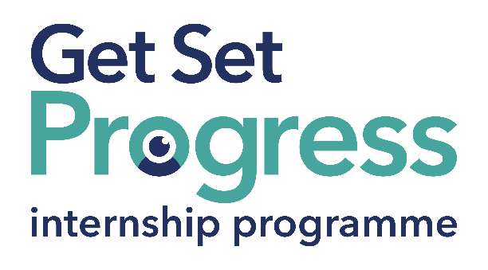

Why should your organisation hire a visually impaired intern?

Who are we?
We are the Thomas Pocklington Trust (TPT), we focus on
Education, Employment and Engagement, we support blind and partially sighted people to live the life they want to lead. We are committed to working with partners, developing, implementing activities and services that support visually impaired people to increase independence and improve lives.

The GSP Programme:
TPT has been running the highly successful Get Set Progress Internship programme since 2015.
GSP Programme Aims
- Increasing employment opportunities for blind and partly sighted people
- Helping breakdown workplace barriers between employers and blind or partly sighted employees

The GSP programme provides the right support to facilitate a blind or partially sighted intern into any role within your organisation.
85% of former GSP interns have secured full-time employment after completing the programme.

Why should you get involved?
Partially sighted people are an underrepresented group within the UK workforce.
The GSP will allow your organisation to tap into this vastly talented and tenacious pool of potential candidates whom you may have struggled to reach through traditional selection and recruitment methods.

The GSP can support interns in any potential role, some former GSP interns have held successful positions in:
- Marketing
- Finance
- Social media
- Customer services
- Technology

As a GSP partner organisation, you’ll realise the understated talents that visually impaired people have and how they can become valuable members of your team and an asset to your organisation.

Many of those with visual impairments become advocates for their host organisations shedding positive light on their experiences as well as promoting an employer as truly open to diversity and equality.

Key benefits of being a GSP partner:
- Building disability confidence
  - Hosting a visually impaired intern can help to increase your organisation's awareness of how best to cater for disabled employees. With our guidance, training, support straightforward advice and new perspectives you will be ready to improve your organisation's approaches towards Visual impairments.
- Funding
  - Up to 50% of a potential intern’s salary could be funded.
- Support
  - TPT will support you every step of the way from helping to select an outstanding candidate to developing their workplace skills through our vigorous L&D programme.
- Customer relatability
  - Your organisation is more than likely to work with or serve disabled people. No matter a person's disability the relatability some customers or clients may find knowing you're an open-minded and forward-thinking organisation will be truly beneficial. For example, the Purple Pound is worth an estimated £249 billion a year* meaning that there is potential commercial gain to be made.
The Purple Pound relates to the spending power of disabled households in the UK.

Don’t just take our word for it hear from previous and current GSP hosts:
"Witnessing the profound impact of these internships not only on the individuals themselves but also us as an organisation, we are reminded that true success lies in embracing diversity and creating a society where everyone, regardless of visual impairment, can fully participate and live life to the full.”
Cate Burke, CEO of Focus Birmingham

"The experience of having a GSP intern has been very positive. TPT has supported us along the way and our intern has already made a massive impact on our organisation and our work."
Mark Upton, CEO of My Vision Oxfordshire

What about the GSP interns?
“The GSP has Improved my confidence, enabling, and encouraging me to pursue my career ambitions. I now feel informed, equipped and excited to embrace future employment opportunities!”
Emily Lamb, GSP Intern at Focus Birmingham

"TPT’s support through the Get Set internship programme has provided me with the confidence and knowledge on how to approach job applications and interviews."
Charlie Allen, Communications and Administration Intern at Blatchington Court

Are you ready to embrace exciting new talent in your organisation? sign up to get started as a GSP internship partner!
If this seems like something that your organisation would be interested in you can sign up online through Thomas Pocklington Trusts Grants Portal to host a GSP intern or find out more by getting in touch today!

Sign up to host an intern by Visiting the TPT Grants Portal

For more information, please get in contact: internships@pocklington-trust.org.uk

Visit our website for more information: https://www.pocklington-trust.org.uk/employment/internships/

