With any career related activity, you should always check the following to be more inclusive …
Senses | - Are your SEND pupils comfortable in the environment?  - Are the sounds, smells and visuals tolerable?  - Is the lighting suitable?  - Has room layout been considered?  - Do some pupils need equipment to support, ear defenders , screen filter room divider etc  - Is the room to noisy, busy, crowded?
Time | - Has appropriate time been allowed for tasks?  - Have you allowed time for reflection?  - Are time scales realistic, do pupils know the time scales?  - Have pupils been prepped if needed?  - Have they had more time?  - Keep requests to do things quickly kept to a minimum with the option to opt out of having to respond rapidly
The career task, event or session itself  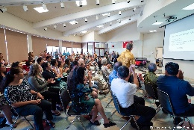 | - Is everything required in a task/session made explicit prior?  - Is the career activity based upon implicit understanding which draw upon social norms or typical expectations?  - Is it clear which tasks should be prioritised over others?  - Make sure pupils can ask questions so they are clear.  - Assign a TA to support /prep SEND pupils.  - Can resources and materials be sent in advance?  - Can group activities be adjusted to enable everyone to take part.  - Do any employers or providers involved know about pupils SEND needs for example -. Does everyone in the environment recognise that a reluctance to engage socially does not imply dislike or rudeness?  - Would pupils benefit from having a traffic-light system (e.g. green, yellow or red post-it notes) to signal their willingness to interact and / or current stress level?  - Ask the pupils what they need to help them during the activity/session/event.  - Know your pupils, who needs extra help , time or support with planning, flexibility, attention etc.  - Are there any digital tools or other support that could support pupils – time management apps , mind maps , sketches , to do list, task board , picture list etc  - If the career activity involves writing , can any alternatives be offered to record their learnings.  - Provide handouts rather than copy off board – make sure they are in accessible formats.  - Repeat instructions/tasks.  - Provide assistive technology.  - Break down sessions into smaller chunks.  - giving pupils more time to do written or reading if part of the activity.

Ideas of how you can be more inclusive during specific career activities …

Career Activity | Things to think about. Are you being Inclusive? Reasonable Adjustments
Workplace visit | - Sharing information in advance about what to expect from the visit.  - Send photos/show video of the workplace to provide predictability and familiarity.  - Ask the pupils!! Please let me know if I can do anything to help you participate in the workplace visit? What will support you?  - Give pupils a chance to ask questions and give them clear answers.” “Explain the unwritten rules. Tell them about the culture or protocols of a workplace.  - Provide a buddy or mentor to support on the visit.  - Prep the workplace of pupil needs, can they offer a breakout room.
Visit to a college or training provider.  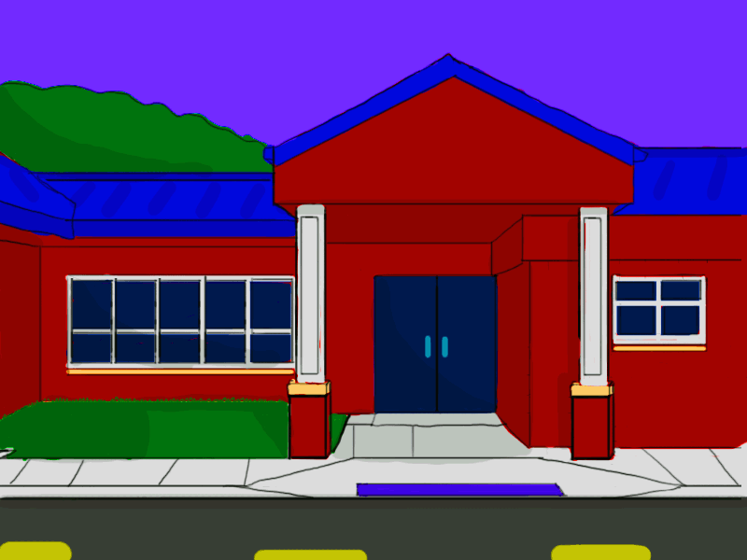 | - Sharing information in advance about what to expect the visit.  - Send photos/show video of the setting to provide predictability and familiarity.  - Produce a flow chart/visual flow chart of what will happen during the visit.  - Ask the pupils - Please let me know if I can do anything to help you participate in the college/training provider visit ? What will support you?  - Give pupils a chance to ask questions and give them clear answers prior to the visit, during and after.  - Provide a buddy or mentor to support during the visit.  - Prep the college /provider regarding pupil needs – what can they do to support?
Career talk | - Sharing information in advance about what to expect the session, who is the speaker, what will they talk about , why they are coming etc- set the scene so the pupils know what to expect.  - Provide a photo if possible prior of the speaker.  - Ask the pupils!! Please let me know if I can do anything to help you participate in the session. What will support you?  - Prep some questions with students prior so they are ready for the session.  - Provide a buddy or mentor to support.  - Could the career speaker be invited to a smaller session so not whole year group? Could the speaker talk to SEND pupils separately?
Work related project /Enterprise challenge.  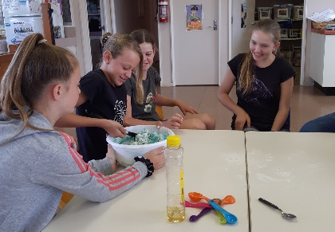 | - Sharing information in advance about what to expect from the project, what are the expectations, agenda for the project, who will be involved and when?  - Produce a flow chart/visual flow chart of what happens during the session, what they can expect.  - Ask the pupils Please let me know if I can do anything to help you participate in the project, What will support you?  - Give pupils clear tasks and structure. What am I doing? Why am I doing it? What do you want the result to be?  - Provide a buddy or mentor to support the activity /challenge.  - Play to the students strengths what role could they do to give them confidence.
Career or next steps assembly  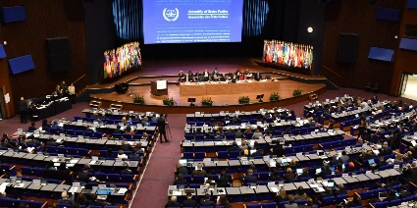 | - Sharing information in advance about what to expect the assembly, who will be delivering the assembly, why and how long etc.  - Ask the pupils Please let me know if I can do anything to help you participate in the assembly. What will support you?  - Provide a buddy or mentor.  - Do some research with the pupil prior of who is speaking.  - Help them prep some questions they may be able to ask during the assembly – can questions be submitted prior.  - Do they need to attend a large assembly? could the session be done separately for SEND pupils?
Work Experience | - Sharing information in advance about what to expect from work experience.  - Send photos/show video of the workplace to provide predictability and familiarity.  - Arrange a pre visit with support.  - Ask the pupils, Please let me know if I can do anything to help you participate in work experience ? What will support you?  - Give pupils a chance to ask questions and give them clear answers.” “Explain the unwritten rules. Tell them about the culture or protocols.  - Provide a buddy or mentor or work coach.  - Provide a thorough induction or support plan. Help pupils get to know the building; where they might sit; who they will work with; what to expect; and different staff roles.  - Travel training to the workplace.  - Talk to employer about making adjustments to tasks to suit the needs of the learners.  - Book pop up shops / Black Country careers hub café for SEND learners with higher needs to ensure they get the support and a positive experience.
Mock interview | - Sharing information in advance about what to expect the session.  - Send photos if possible, of mock interviewer and the room they will meet in, to provide predictability and familiarity.  - Produce a flow chart/visual flow chart of what happens during a mock interview what they can expect.  - Think about the room you will meet in. For example, can you control the light or the temperature? Is the room full of clutter? Are you likely to be disturbed or interrupted by external noise? These have potential to impact the interaction.  - You can ask the young person the following questions if it will help them to feel comfortable and engage in the interview :Would you prefer the lights turned on or off? • Do you need to wear sunglasses, ear defenders or use a stim toy (see glossary of terms)? • Would you prefer the meeting room door to be open or closed (subject to safety and security)?  - Minimise distractions (phones, people walking past, people interrupting the interview).  - Ask the pupils!! Please let me know if I can do anything to help you participate in the session. What will support you?  - Provide a buddy or mentor to support during the interview.  - Prep the interviewer, of pupil needs.  - Give pupils questions they will be asked in advance.
Career Event/Fair | - Sharing information in advance about what to expect at the career fair.  - Ask the pupils!! Please let me know if I can do anything to help you participate in the session. What will support you?  - Provide a buddy or mentor to go around the fair with them.  - Can they access the fair at a quieter time?
Career Speed Networking | - Sharing information in advance about what to expect the networking session.  - Ask the pupils!! Please let me know if I can do anything to help you participate in the session? What will support you?  - Provide a buddy or mentor to go from table to table to support.  - Can they access the event at a quieter time – SEND friendly session.  - Prep questions they can ask prior to the session.
- Career Advisor Meeting | - Sharing information in advance about what to expect the session.  - Produce a flow chart/visual flow chart of what happens during a 1-1 career advise meeting, what they can expect.  - Ask the pupils!! Please let me know if I can do anything to help you participate in the session. What will support you?  - Send a TA / support worker with the pupil who knows the pupil well.  - Complete a one-page profile or vocational profile prior to the 1-1 meeting and share the information prior with the career advisor.

