Collecting and Reviewing Impact Evidence: Guidance Document
What are the different types of impact evidence?
Type of Impact evidence | When to collect and use it | What it tells us | Tools
Feedback | - Soon after the end of career activities.  - From students, parents, teachers, employers, activity providers.  - When activities are new, substantial, or significant in cost/resource (as overuse can undermine engagement). | - The initial reactions of participants about satisfaction, usefulness, enjoyment, perceived impact on next steps.  - Different perspectives. | - Example questionnaires  - Creative ways to gather feedback
Career knowledge  and skills | - At targeted points and infrequently as these indicators improve slowly as a result of many experiences.  - At transition points to inform choices and targeted support. | - Progress towards learning outcomes.  - Preparedness for next steps.  - Gaps in knowledge and skills that can be addressed through further support.  - Changes for cohorts and individuals in relation to career programmes. | - Future Skills Questionnaire  - Compass+  - Skills Builder Benchmark Tool  - Measures of personal development
Education engagement | - As needed to check how careers learning informs curriculum engagement.  - More frequently for students at risk of disengagement or poor academic outcomes. | - Progress in engaging students at risk of poor outcomes.  - Impact of career programme and targeted activities on engagement with learning. | - End of unit / year tests  - Termly / annual effort grades  - Teacher reports  - Public exam results  - Bespoke survey using questions about engagement
Destinations data | - Collect intended destinations during final one or two years of school/college.  - Actual and sustained destinations for leavers.  - Maintain for 3 years after school.  - Access published destinations measures annually. | - Pathways for students according to cohort, disadvantage, gender, attainment.  - Trends year on year in relation to the career programme and wider education.  - Suitability of pathways for groups of students. | - Compass+ data on intended and actual destinations  - Published DfE destinations measures for 1, 3 and 5 years after Key Stage 4 and for post-18

- Feedback

What does it cover?
Feedback is the most light-touch form of impact evidence.
When collected during or soon after the end of an activity, it provides a snapshot insight into how students reacted to the activity and can be useful for understanding how engaged they were, how much they enjoyed it, how relevant and useful they found it, and what they plan to do as a result.
Gathering feedback is a good way to capture the different perspectives of those involved in an activity and creating a rounded picture.
Gatsby Benchmark 1 requires Careers Leaders to consider feedback on the careers programme from students, teachers, employers, and parents/carers. This could involve combining feedback on individual activities (for example, where an employer delivers careers talk) or for reflective views on the progressive career programme as a whole.
Feedback evidence usually focuses on opinions, perceptions, and attitudes. Other forms of evidence are needed to capture actions such as choice of pathway, research into careers or skill development.

How do I collect feedback data?
Collecting feedback can be quick and creative. The time invested by you as the Careers Leader as well as by those providing feedback should be proportionate to the activity and the use you’ll make of the resulting evidence.
The approaches below can be useful for keeping students engaged in an activity as well as for gathering feedback.
Compass+
Vary the approaches used to retain interest and avoid the fatigue that comes with over-use.
Refer to the Evaluation Guide for Careers Activities and Programmes
Developed by the team in Swindon and Wiltshire Careers Hub, this resource supports Careers Leaders with approaches to feedback and effective evaluation of their careers programme. There is a longer guide for Careers Leader available along with a shorter quick reference version

- Feedback surveys
Surveys are valuable for quantifying feedback – understand how many or what proportion of participants reacted in different ways to an activity or the careers programme. They are valuable for gathering frank and honest feedback (anonymity can be helpful for this) and when the audience is remote or dispersed (such as parents/carers).
Surveys are most valuable when:
- Questions are clear, short, targeted at the audience and consistently interpreted (see guidance on questionnaire design here)
- Response is high (so you can be sure your data are representative)
- You know the range of possible responses and can provide closed questions with answer options
- Used sparingly (to avoid survey fatigue)

To support Careers Leaders with impact evaluation, we have created a guidance document on ‘How to write your own survey questions’ with example survey templates that Careers Leaders can use when collecting feedback and programme evaluation insight from a range of stakeholders.

Feedback from parents
Gathering feedback from parents can be challenging. Options to consider are:
- Incorporating some high-level questions in a school or college’s annual survey of parents/carers.
- Using QR codes and quick methods such as putting traffic light cards in a box at the end of an event.
- Using polling tools within Teams and Zoom for online events.
- Informal chats and requests for feedback when in touch with parents, e.g., in EHCP reviews or at parents evening.

Informal data collection
The methods above can be complemented with informal conversations in person, via email or as part of student council meetings or networking events. Remember to record and save so that we can review later in the year.
How can I use the evidence to evaluate my programme?
This is ‘real time’ information that you can use throughout the year to form a quick judgement on how well an activity was received by all involved, how well it met the needs of students and what adaptations might be needed as a result.
Consider the full range of perspectives and reasons for the responses. Student engagement is generally a good indicator of the potential value of an activity but remember that important learning can take place despite an activity being hard or tiring.
Try to understand the reasons for responses so that you can adjust accordingly.
Make a note of responses and collate so that you can review by theme ahead of planning the programme for the following year. This collated evidence can help you to meeting Gatsby Benchmark 1 – considering feedback on the careers programme.
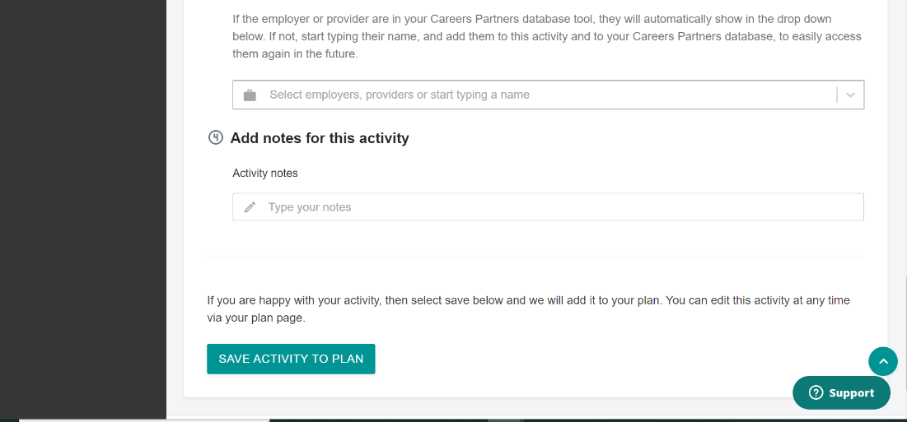
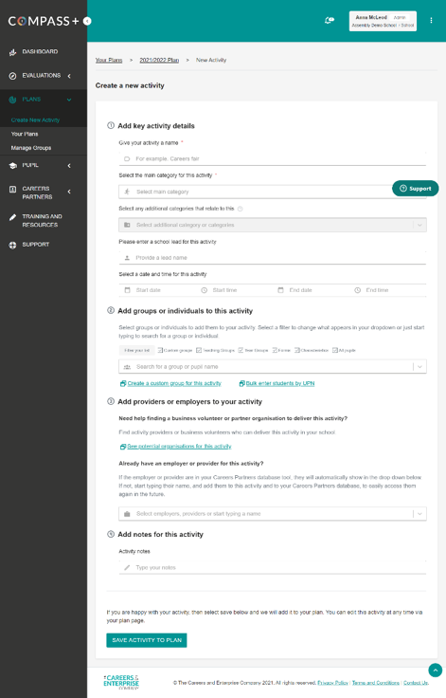
Evaluating the Evidence: Example Reflective Questions (Feedback)
- From stakeholder ‘key event’ feedback’ what went well?
- From stakeholder ‘key event’ feedback’ what improvements could be made to careers programme?
- What were the key positive / negatives from stakeholders including students, parents/carers, employers, staff, etc?
- What was the quality of the employer engagement activities?
- How could the quality of employer engagement be improved?
- Which employers might you re-engage next year?

- Career knowledge and skills

What does it cover?
Career knowledge and skills are the learning outcomes of career programmes. Similar to curriculum subjects, the delivery of careers education should be targeted at supporting students to develop specific knowledge and skills which is defined according to what is needed for a successful career. These are ‘proximal outcomes’ as they start to develop while a young person is in education, continue throughout life and are a stepping-stone towards education and employment outcomes.
Frameworks
The CDI Career Development Framework sets out six learning areas that are linked to the intent of the Gatsby Benchmarks and align with the Quality in Careers Standard. Accompanying guidance articulates target learning outcomes at each key stage which can be used to plan careers activities and measure their success.
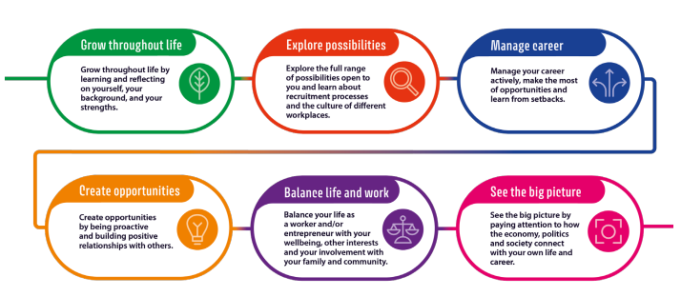

The Universal Skills Builder Framework supports the development of eight essential skills which are divided into sequential steps. The website provides tools and resources for educators, employers, and individuals for tracking progress and developing each skill.
The Skills Builder Benchmark Tool can be used to facilitate targeted essential skills education and to measure the impact of skills-building activities:
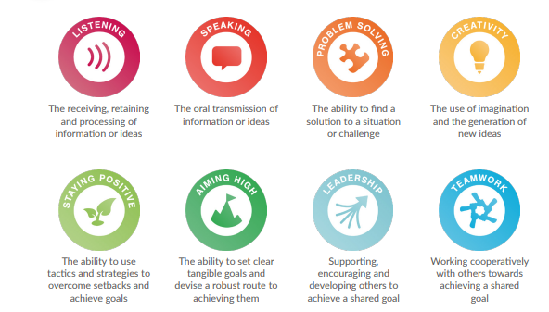

Other relevant frameworks include the Personal, Social and Health Education (PSHE) curriculum provided by the PSHE Association.

How do I collect knowledge and skills data?
Future Skills Questionnaire
There are different ways to assess how well students are progressing towards the learning outcomes of careers education including formal assessments of knowledge, observations, and reflections (from teachers, careers advisers, parents/carers, and employers), and the perceptions of young people themselves. Self-development aspects of learning outcomes, such as self-belief and self-efficacy, can be measured through standardised psychometric tools which have been collated by the Education Endowment Foundation in the SPECTRUM Database.
The Careers & Enterprise Company has developed a measurement tool called the Future Skills Questionnaire to provide a quick and simple solution to tracking careers education learning outcomes from a student perspective. The FSQ is available to secondary schools who use the Compass+ career management digital tool. The questions cover labour market awareness, seeking advice and guidance, planning and choosing, and transition skills. There is also a section about essential skills based on the Skills Builder framework. The questions were developed with reference to existing frameworks and in consultation with careers practitioners and sector experts. They were tested with 3,500 students and in-depth cognitive testing was carried out with 40 students.
Versions are tailored for points of transition – start of Year 7, GCSE choices time, end of Year 11 and end of 16-18 study – so that the questions are relevant. There is a maximum of 25 questions. The SEND version has 14 questions and is designed to be completed as part of a conversation. The scores for individuals and average scores for cohorts indicate the extent to which students are on track with knowledge and skills development and where there are gaps.
The Future Skills Questionnaire is embedded within Compass+ enabling students’ responses to be saved back to their profiles and viewed alongside student characteristics. Data visualisations within the tool will allow Careers Leaders to view the combined responses for year groups and compare responses by gender.
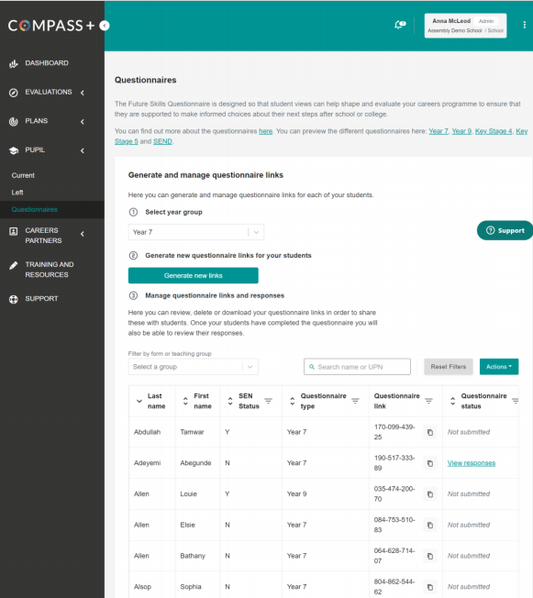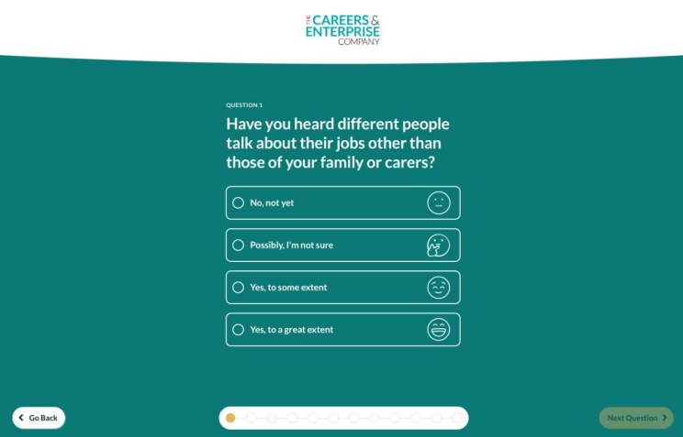
Colleges
Careers Leaders in colleges do not have access to the full functionality of the FSQ because Compass+ is only for schools. However, Careers Leaders helped shape the 16–18-year version to ensure its relevance for college students (and some Careers Leaders thought the Key Stage 4 version might be suitable for some Level 2 learners). The questions and accompanying guidance will be made available on The Careers & Enterprise Company website to enable colleges to programme the tool in their own software.
Some colleges also have access to diagnostic tools within programmes such as ProMonitor.
Evaluating the Evidence: Example Reflective Questions (Careers Knowledge & Skills)
- What do the FSQ scores show about progress across different transition points?
- Does FSQ show progress with year on year with responses at key transition points?
- Does FSQ show similar scores by vulnerable groups including gender and disadvantage?
- Can associations be identified from FSQ scores between career programme changes and scores?
- From FSQ scores, what should be focus on going forward according to questions with more negative responses?
- Does FSQ show that students aware of all routes available to them at 16/18?
- Does FSQ show that there is alignment of career interests with local skills needs?
- From FSQ scores, which students require additional support to make positive transitions?

Additional Tools, Resource and Support
Other questionnaires include the Student Career Readiness Index, which was used in the Evaluation of the Northeast pilot of the Gatsby Benchmarks. The Student Career Readiness Index (SCRI) is a nine-item scale which is valid measure of career readiness. More information and the questionnaire items can be found here. The Gatsby report that references the tool can be found here.

- Education engagement
What does it cover?
Engagement in curriculum learning and academic attainment are recognised by Careers Leaders and senior leaders as important outcomes of careers education that support young people to achieve successful careers. There is considerable evidence to show that careers education can support education outcomes by demonstrating the relevance of academic learning and effort for employment and increasing interest in curriculum subjects, particularly for the most disadvantaged and disengaged students.
Indicators of engagement include:
- School or college attendance rates
- End of unit / end of year assessment grades
- Effort grades from teachers and staff
- Behaviour referrals/rewards information
- Student perceptions of learning, interest in subjects, and self-reported behaviours such as time spent on homework
- Public examination results such as pass rates in GCSEs and Level 3 courses

How do I collect education engagement data?
Careers Leaders can gather education data from institution records or directly from colleagues. In many schools and colleges, Careers Leaders work closely with pastoral teams, student services and progression coaches so will have ready access to education data. It is likely to be most fruitful to focus on students who have lower engagement and attainment rates, where there is greatest potential for the careers programme to have an impact.
School and college level attainment results can be accessed from the DfE website and explored for patterns between groups of students and over time. Reports for each school include Progress 8 scores (including for disadvantaged students particularly), Attainment 8 scores, and the proportion of students achieving pass grades in English and Maths GCSE. Local authority and national averages are shown for comparison.
If you wish to gather perceptions directly from students, questions can be lifted from well-established surveys, such as:
- Millennium Cohort Study age 11, 14 or 17 (measures school motivation and engagement, plans for future study, aspirations)
How can I use the evidence to evaluate my programme?
Education data can be used to track the extent to which participation in targeted careers activities improves the engagement and attainment of the most vulnerable students and potentially to identify which approaches have been most effective.
Evaluating the Evidence: Example Reflective Questions (Education Engagement)
- Is there education engagement evidence to support value of embedded careers across the curriculum?
- What evidence exists to show increased educational engagement following careers activities for cohorts, specific groups or for individuals?
- Has a particular initiative/activity been effective in improving educational engagement?
- Is the Careers Leader aware of where the need is in educational engagement so that careers activity/interventions can be planned to support cohorts, specific groups or individual students?
- Destinations data
What does it cover?
- Intended destinations: student plans before they leave school or college.
- Actual destination: where students transition to.
- Sustained destinations: the pathway students are in for the 6 months between October and March after leaving school.
- Subjects, pathways, and institutions: more detail about the where and what students are learning.
Careers Statutory Guidance: Schools
- Schools should collect and maintain accurate data for each pupil on their education or employment destinations for at least three years after they leave school, or from the end of KS4, whichever is sooner
- Schools should work with their local authority as they collect and collate destinations data and establish an effective data-sharing agreement.
- Reflection: Does your school have a system in place for tracking students’ destinations for 3 years post KS4?

We know that the collection of destination data can be challenging for schools. DfE intend to update their good practice guide, providing clearer guidance on the lawful basis for processing students destinations data

CEC Resources and Support:
Engage with your local authority and FE providers to collect and collate destinations data and establish an effective data- sharing agreement:
- Read our published report ‘Review of local destinations data’.
- Read our report ‘The benefits of Gatsby Benchmark achievement for post-16 destinations’.
- Read our case study ‘School Destination Report 19/20 Example’
- Encourage your Careers Leader to use the destination tracking function on Compass+.
Careers Statutory Guidance: Colleges
Colleges should collect and maintain accurate data for each pupil on their education, training, or employment destinations.

Reflection: Does your college have a system in
place for tracking students’ destinations?

How do I collect destinations data?
Gatsby Benchmark 3 requires schools to collect the destinations of students for 3 years after they finish Key Stage 4. Colleges are required to track the destinations of their students, with a minimum requirement to record their onward destination.
Schools and colleges should collect and analyse education, training, and employment destinations data for all students. This data may help schools and colleges to identify pathways, subjects or courses with low take-up that could be addressed by changes to the careers programme.
Compass+ provides a structure for schools to do this and colleges have separate systems. There are fields to record details about intended and actual destinations and some simple visualisations which will be further developed as the tool becomes established. For more information on using these Compass+ visualisations, please click here.

Key Stage 4 Key Stage 5

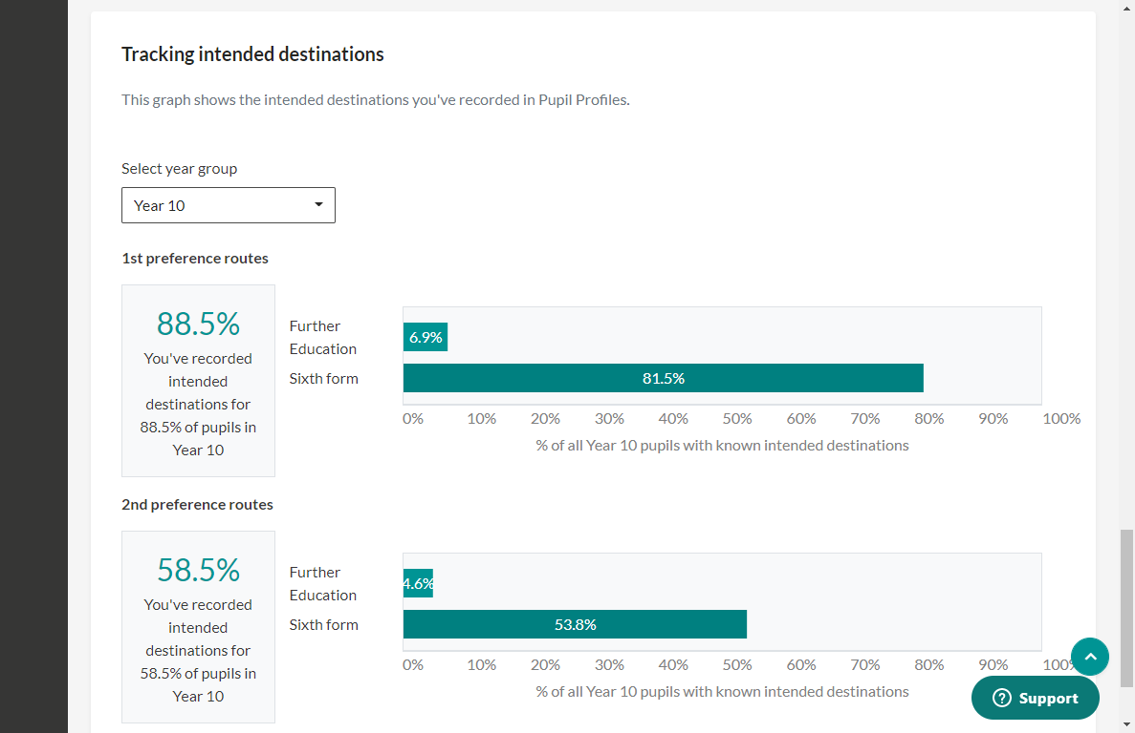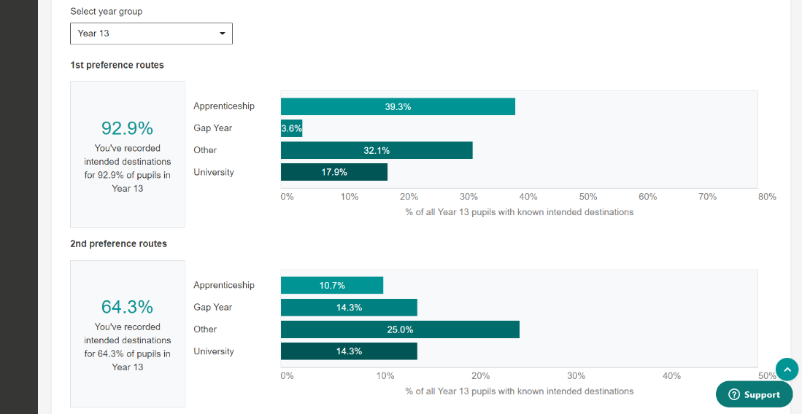

There is currently uncertainty as to the appropriate lawful basis for processing student destinations data. The DfE may clarify this in their forthcoming revised good practice guide or they may leave it to each school, special school and college to determine with their Data Protection Officer. If the lawful basis is consent, then there are stipulations set out by the ICO that need to be followed. It may be possible to use another basis such as legitimate interest.
Recent research identified that schools and colleges use a range of approaches to collecting intended destinations including through personal guidance interviews or student questionnaires.
Actual destinations for 16- and 17-year-olds can be requested from Local Authorities who have a duty to collect this information to submit to the National Client Caseload Information System. It is not a statutory duty for LAs to share this information with schools, but many areas do so under a Data Sharing Agreement.

Tracking destinations in the third year for 18-year-olds is challenging. Schools and colleges achieving this tend to use a range of approaches including social media, and alumni networks.
School and college level destinations data can also be accessed here from the DfE website, following a time lag in data collation and preparation.
Please access our Resource Directory for additional Resource and Support with collecting and reviewing Destination Data
Evaluating the Evidence: Example Reflective Questions (Destinations Data)
- To what extent do students have an appropriate intended destination as they approach the end of school, special school, or college? Are there any cohorts, specific groups or individual students who require additional support?
- Is intended level of study aligned to student attainment?
- Are there gaps according to disadvantage, gender, or ethnicity gaps in intended or actual pathways including technical education, higher education, STEM, etc.?
- A re there gaps according to disadvantage, gender, or ethnicity gaps in outcomes three years after leaving school including technical education, higher education, STEM, etc.?
- Are there trends in NEET and EET in relation to the careers programme and/or changes made to the careers programme?
- Are intended destinations aligned with local skills needs and national growth sectors?

Activity:
“Embedded in our self-evaluation I want to know how destinations at 16 relate to student attainment and prior attainment. Where trends have emerged that reflect low aspiration or potential issues around stereotypical thinking, we address that in our curriculum and our Careers Leader builds this into future planning to continuously strengthen destinations and therefore life chances for our students”
Dawn Parkinson, Headteacher Beaumont Leys School

Careers Provision SOAR: Strengths, Opportunities, Aspirations, Results
Elements to plot:
- Time/Resource of Careers Leader, Role of EA/Link Governor, Parental Engagement, SLT Buy-in, Staff CPD, Whole School Responsibility for Careers.
- Benchmark progress: LMI, Tracking at Student Level, Careers within Subject Areas, Employer Engagement, Experiences of the World of Work, Encounters with FE/HE, 1:1 guidance.
- Reviewing Evidence*: Feedback, Careers Skills & Knowledge, Education Engagement and Destinations Data.

* Consider your answers to the reflective questions throughout this document as you review evidence to plot in this SOAR analysis
Strengths | Opportunities
Aspirations | Results
Key priority/action areas from SOAR:

The SOAR tool is taken from the Building a Strategic Careers Plan Guidance Document

