*This survey is intended to gather feedback from students following an employer encounter event. It gathers student perceptions on the organisation, engagement, and impact of the event.

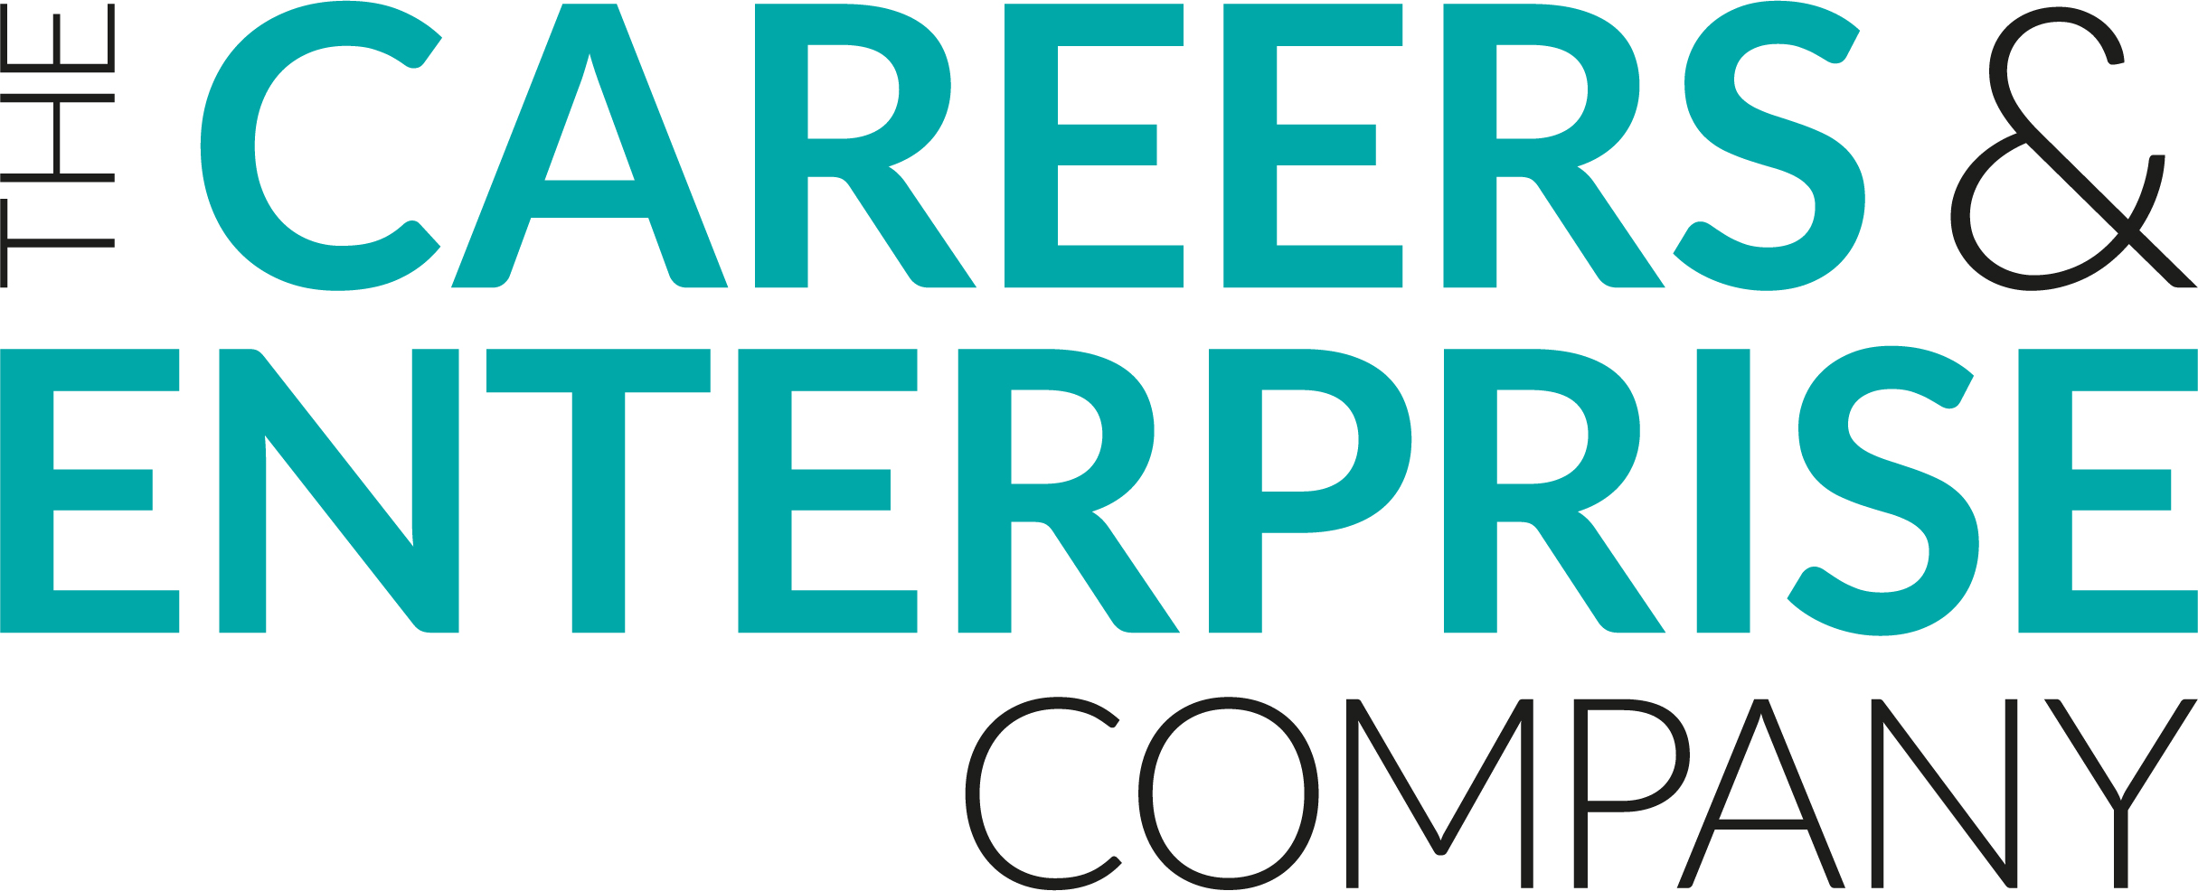
Meaningful Encounter Feedback
Student

Student Name:
Event Title:
Year Group/Key Stage:

- Did you feel well prepared for this event?
Yes, to a great extent | Yes, to some extent | Possibly, I’m not sure | No, not at all
- Did you understand the purpose of this event?
Yes, to a great extent | Yes, to some extent | Possibly, I’m not sure | No, not at all
- Did you enjoy this event?
Yes, to a great extent | Yes, to some extent | Possibly, I’m not sure | No, not at all
- Was the event relevant to your interests?
Yes, to a great extent | Yes, to some extent | Possibly, I’m not sure | No, not at all
- Did you feel that you could relate to the speaker?
Yes, to a great extent | Yes, to some extent | Possibly, I’m not sure | No, not at all
How much do you agree with the following statements?

- This event has helped me to understand something about careers and the world of work
Strongly agree | Agree | Neither Agree nor Disagree | Disagree | Strongly Disagree
- The event improved my understanding of the knowledge and skills needed by employers
Strongly agree | Agree | Neither Agree nor Disagree | Disagree | Strongly Disagree
- This event has helped me to develop essential skills (i.e. listening, presenting, problem solving, creativity, staying positive, aiming high, leadership, teamwork)
Strongly agree | Agree | Neither Agree nor Disagree | Disagree | Strongly Disagree
- This event helped me think about what I might like to do once I finish school or college
Strongly agree | Agree | Neither Agree nor Disagree | Disagree | Strongly Disagree
- This event has changed my thinking about my future plans
Strongly agree | Agree | Neither Agree nor Disagree | Disagree | Strongly Disagree
- Are there any actions you intend to take as a result of this event?
- What went well about this event?
- How could this event be even better?

