*This survey is intended to gather feedback from school staff on the careers programme. It gathers staff perceptions on the support offered to them to deliver careers learning by the school/ college and the impact of the careers programme on students.

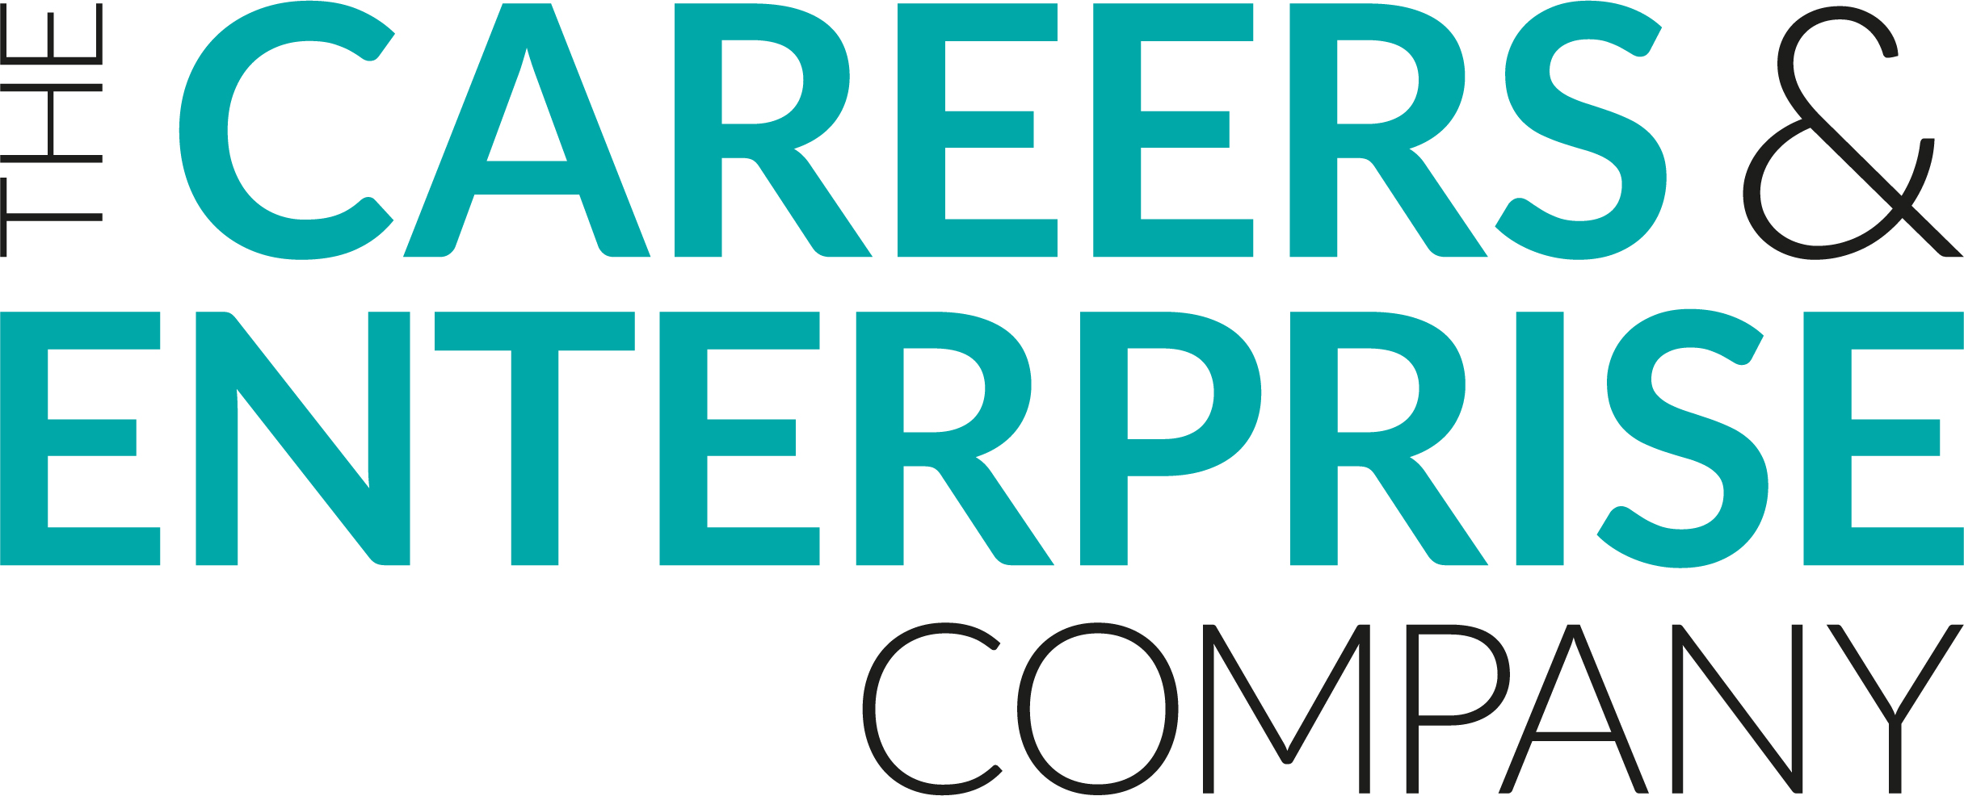
Careers Programme Evaluation Staff

Name:
Department:

To what extent do you agree with the following statements:

- I understand the focus areas for careers provision in the school/college
Strongly agree | Agree | Neither Agree nor Disagree | Disagree | Strongly Disagree
- The careers programme has clear links to school/college priorities
Strongly agree | Agree | Neither Agree nor Disagree | Disagree | Strongly Disagree
- I understand my role in relation to the careers programme at the school/college
Strongly agree | Agree | Neither Agree nor Disagree | Disagree | Strongly Disagree
- I understand how to access and use labour market information about jobs and opportunities locally and nationally
Strongly agree | Agree | Neither Agree nor Disagree | Disagree | Strongly Disagree
- I feel well informed on the range of career pathways relevant to my subject area
Strongly agree | Agree | Neither Agree nor Disagree | Disagree | Strongly Disagree
- I feel well informed on the range of learning pathways at key decision points (GCSE Options, Post 16, Post 18, etc.)
Strongly agree | Agree | Neither Agree nor Disagree | Disagree | Strongly Disagree
- I feel supported to embed learning about careers into my lessons
Strongly agree | Agree | Neither Agree nor Disagree | Disagree | Strongly Disagree
- Students are well supported to make informed decisions at key decision points
Strongly agree | Agree | Neither Agree nor Disagree | Disagree | Strongly Disagree
- The careers programme supports students to develop essential skills e.g., listening, presenting, problem solving, creativity, staying positive, aiming high, leadership, teamwork
Strongly agree | Agree | Neither Agree nor Disagree | Disagree | Strongly Disagree
- The careers programme supports students to understand careers and the world of work
Strongly agree | Agree | Neither Agree nor Disagree | Disagree | Strongly Disagree
- What works well about the careers programme?
- How could the careers programme be even better?
Thank you for completing this form, we really value your feedback in continuing to develop our careers programme

