*This survey is intended to gather feedback from students following a personal guidance interview. It gathers students’ perceptions on their preparedness, organisation, and impact of their personal guidance interview.

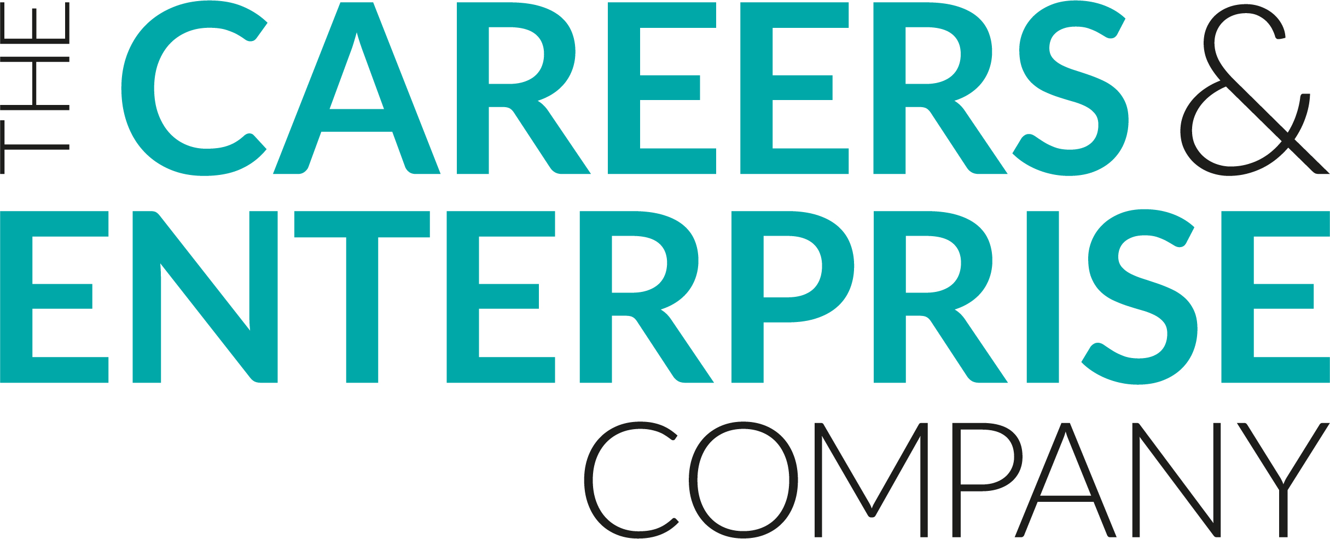
Personal Guidance Feedback
Student

Student Name:
Event Title:
Year Group/Key Stage:

- Did you feel well prepared for your personal guidance interview?
Yes, to a great extent | Yes, to some extent | Possibly, I’m not sure | No, not at all
- Do you understand the purpose of your personal guidance interview?
Yes, to a great extent | Yes, to some extent | Possibly, I’m not sure | No, not at all
- Did you enjoy your personal guidance interview?
Yes, to a great extent | Yes, to some extent | Possibly, I’m not sure | No, not at all
- Did you talk about things that were relevant to you?
Yes, to a great extent | Yes, to some extent | Possibly, I’m not sure | No, not at all
How much do you agree with the following statements?

- As a result of the session, I am more aware of different career and learning pathways
Strongly agree | Agree | Neither Agree nor Disagree | Disagree | Strongly Disagree
- As a result of the session, I feel more prepared to make decisions about my career and learning pathway
Strongly agree | Agree | Neither Agree nor Disagree | Disagree | Strongly Disagree
- As a result of the session, I understand more about the knowledge and skills needed by employers
Strongly agree | Agree | Neither Agree nor Disagree | Disagree | Strongly Disagree
- As a result of the session, I understand how my skills and experience relate to my future career
Strongly agree | Agree | Neither Agree nor Disagree | Disagree | Strongly Disagree
- As a result of the session, I understand how my studies relate to my future career
Strongly agree | Agree | Neither Agree nor Disagree | Disagree | Strongly Disagree
- This session helped me think about what I might like to do once I finish school
Strongly agree | Agree | Neither Agree nor Disagree | Disagree | Strongly Disagree
- This session has changed my thinking about my future plans
Strongly agree | Agree | Neither Agree nor Disagree | Disagree | Strongly Disagree
- Please reflect here on what you have learned in this session

