*This survey is intended to gather feedback from employees following an employer encounter event. It gathers employee perceptions on the organisation and impact of the event.

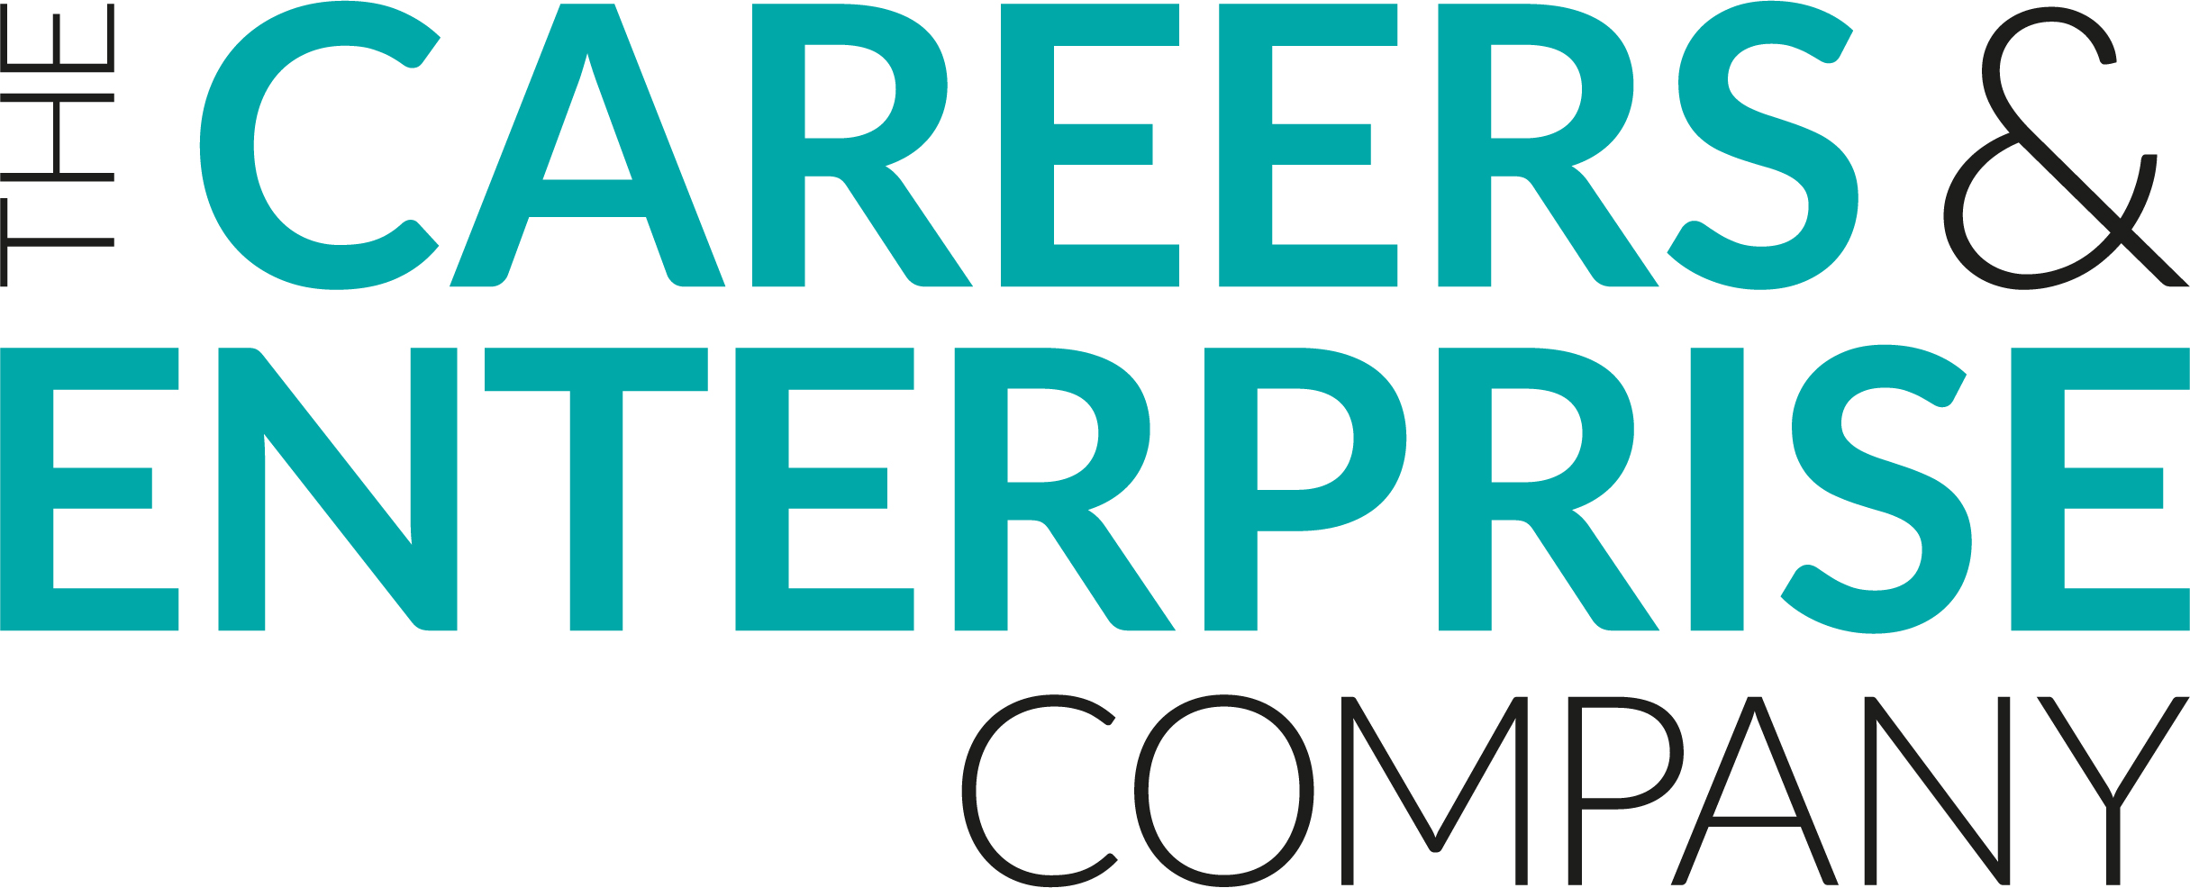
Meaningful Encounter Feedback Employer
Employer Name:
Event Title:
Organisation Name:

To what extent do you agree with the following statements:

Preparation & Intent
- I was well prepared for this event
Strongly agree | Agree | Neither Agree nor Disagree | Disagree | Strongly Disagree
- I understood the purpose of this event
Strongly agree | Agree | Neither Agree nor Disagree | Disagree | Strongly Disagree
Organisation and Implementation
- School staff had been well prepared for the event
Strongly agree | Agree | Neither Agree nor Disagree | Disagree | Strongly Disagree
- Students were engaged in the event
Strongly agree | Agree | Neither Agree nor Disagree | Disagree | Strongly Disagree
- Students asked relevant questions
Strongly agree | Agree | Neither Agree nor Disagree | Disagree | Strongly Disagree
Impact
- The event helped me understand the skills and experiences of young people
Strongly agree | Agree | Neither Agree nor Disagree | Disagree | Strongly Disagree
- I feel motivated following this event
Strongly agree | Agree | Neither Agree nor Disagree | Disagree | Strongly Disagree
- I intend to do more student engagement activities following this event
Strongly agree | Agree | Neither Agree nor Disagree | Disagree | Strongly Disagree
- What worked well about this event?
- How could this event be even better?

