♦ Soon, I am going to be going leaving my school and going to a college.

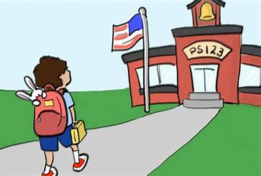
♦ Before I start there, I am going to visit the college
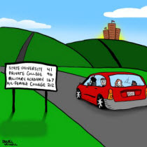
♦ On my visit I will get to meet my new teachers and the other students
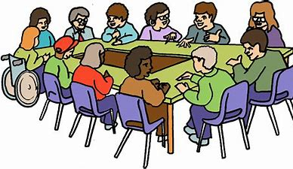
♦ I will also be able to look around the college and see where my classrooms are
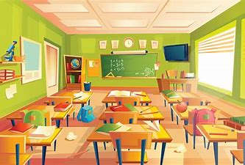
♦ This will help me get ready for when I come to my college
♦ I am going to go to my new college on a bus.
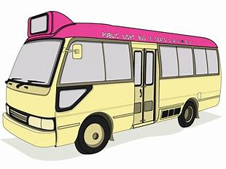
♦ I am going to go to my new college in a car.
♦ I am going to be able to walk to my new college
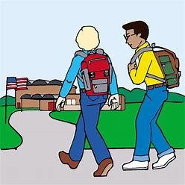
♦ Today I am starting my new college
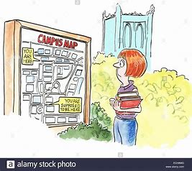

♦ My new teachers are excited to have me in their classes
♦ I can introduce myself to the other students and make new friends.
♦ I can still be friends with the people in my old school too.
♦ Starting a new college is scary and it’s ok for me to get scared.
♦ If I get scared, I can tell my teacher and they will help me.

