There are 3 ways you can use this resource, drawing the lines, matching activity or print off the individual hats and objects in card to support with kinaesthetic learners . Even better if you can obtain any physical resources please use those to bring this activity to life
Choose a hat from row 1, and then an object from row 2 that matches it. Then, choose which skill this profession would need from row 3

Row 1 - Match the hat
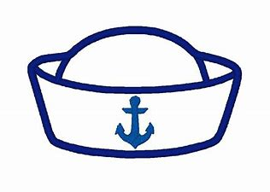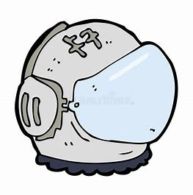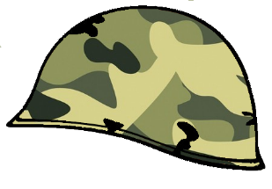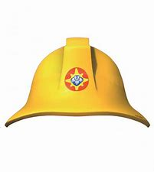

Row 2 – To the object
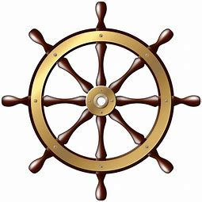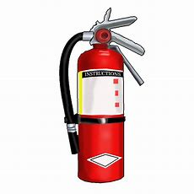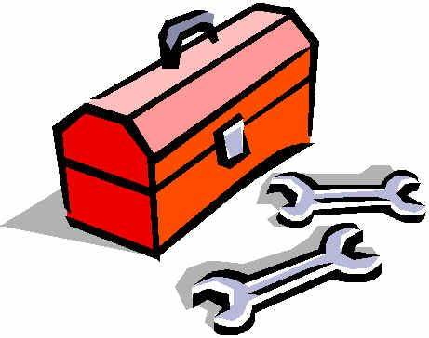

Row 3 – Someone in this profession is good at
Teamwork | Solving problems | English | Staying Focussed | Maths | Being on time | Talking to people | Being organised | Staying Calm

Skill Matching cards to print and cut

Teamwork | Staying Focussed | Talking to people
Solving Problems | Maths | Being organised
English | Being on Time | Staying Calm

