Stourton Park & Ride

Project brief – Renewable energy infrastructure



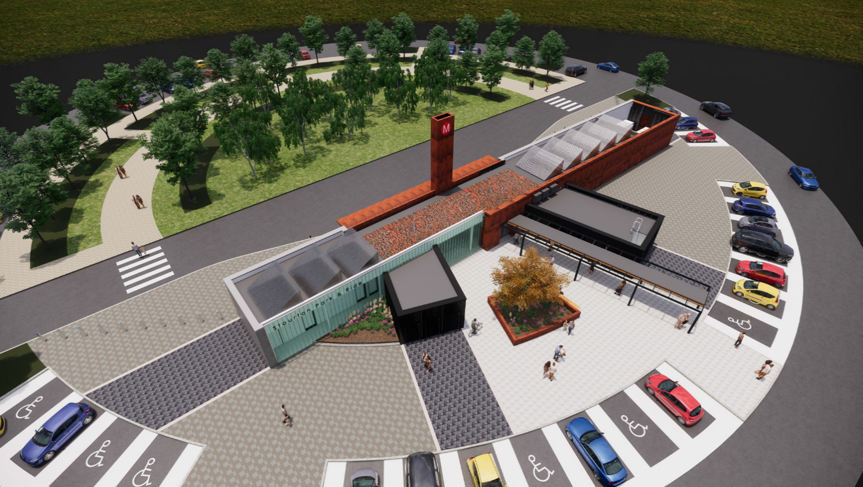

Project Background

Leeds City Council wish to deliver a new Park & Ride scheme to South East Leeds off the M621 and A61 to reduce traffic levels going in to Leeds City Centre. This Park & Ride scheme will compliment existing site at Temple Green and Elland Road.

In order to minimise the environmental impact of the project to the city there is a desire for the buses used to be electric with the terminus building and charge points installed on the site powered by renewable energy. The desire is that vehicles travel to the site using electric power and users get to the city centre using and electric bus, ideally powered by renewable energy.

Site layout

The proposed site layout is below. Key aspects include;

* The provision of a terminus building to the centre of the project
* 1200 spaces are provided
* Areas for planting should be maximised
* A sustainable drainage system will be installed with permeable paving
* A cemetery and housing overlook the site so visual impact is to be minimised
* The site is circular in nature
* The site will have new links off the A61 and M621
* Futureproofing for increased EV charging should be considered, i.e options for more charging on the below site if required.
* The site needs to be adequately lit and have CCTV measure in place so power will be required for this.



Project Brief

You form a design development team who have been tasked to carry out an options appraisal in to Stourton Park & Ride and how it can become a renewable energy hub to meet the environmental goals laid out. The brief looks to analyse the best option for capturing energy, storing it on site and then discharging to electric vehicles.

Phase one will see you completing a design brief that highlights your design ideas of how to capture, store, use, re-store and reuse energy in electric vehicles.

Phase two, after the mid project review, will see you full completing a model single chosen design will data and findings to back up your design choices. You will present your findings and a winner will be chosen based on environmental considerations, efficiency and aesthetics.

The three areas which require analysing and options appraisals are as follows;

1. Generation of power

What options existing to generate the power for the building, bus charge points and vehicle charge points?

You should fully research options and assess them based on;

* Cost
* Energy outputs
* Maintenance
* Health & Safety (construction and maintenance)
* Longevity of use (full life costs)
* Visual impact to the area

1. Storage of power generated

How can the power on site be stored so it is re-used on site rather than connected back to the grid to make it a true renewable energy site.

1. Charging of vehicles

What options exist to charge the buses that will use the site as well as the cars that will park there?

You should fully research options and assess them based on;

* Cost
* Charge Speed (outputs)
* Maintenance
* Health & Safety (construction and maintenance)
* Longevity of use (full life costs)
* Visual impact

LINKS TO GATSBY STANDARDS

3. ADDRESSING THE NEEDS OF EACH PUPIL

Criteria 1 – A school programme should actively seek to challenge stereo typical thinking and raise aspiration.

- BAM commits to achieve this criteria by hosting a launch session to inspire students who have opted to undertake the programme. Roles will be assigned to students within design teams and will be structured to mirror the roles found in the work place to raise aspirations to pursue job types.

4. LINKING CURRICULUM LEARNING TO CAREERS

Criteria 1 - By the age of 14, every pupil should have had the opportunity to learn how the different STEM subjects help people to gain entry to, and be more effective workers within, a wide range of careers.

- BAM can contribute to this criteria exploring the grades required in the different qualifications to fulfil the roles we have to offer at apprenticeship entry level into Civil Engineering and Quantity Surveying. This can be achieved at the launch of the project.

5. ENCOUNTERS WITH EMPLOYERS AND EMPLOYEES

Criteria 1 - Every year, from the age of 11, pupils should participate in at least one meaningful encounter with an employer.

- BAM, for learners opting to undertake this project, can fulfil this criteria by the interactions with colleagues throughout the project.

6. EXPERIENCE OF WORKPLACES

Criteria 1 and 2 - By the age of 16 and 18, every pupil should have had at least one experience of a workplace, additional to any part-time jobs they may have.

Where appropriate, BAM can contribute to criteria 1 and 2 by utilising site visits where safe to do so and appropriate to conclude the project.

Links to curriculum found in the project delivered in a work setting context:

**Maths**

Mensuration – area of squares, diameters, circumferences and radius, volumes to work out costs.

Application of Trigonometry and Geometry – squareness and alignment.

Cartesian Coordinates – plotting circular coordinates.

**Design Technology**

Discrimination shown when selecting and acquiring relevant research that will promote originality in designing.

Excellent understanding and analysis of the design context.

Detailed analysis of relevant existing products or systems undertaken related to design intentions.

Comprehensive analysis of relevant and focused research undertaken.

Clear and specific design criteria identified, reflecting the analysis undertaken.

**Science**

**Energy**

Power as the rate of transfer of energy.

Conservation of energy in a closed system; dissipation.

Calculating energy efficiency for any energy transfers.

Renewable and non-renewable energy sources used on Earth; changes in how these are used.

**Electricity**

Measuring resistance using p.d. and current measurements

Exploring current, resistance and voltage relationships for different circuit elements, including their graphical representations quantity of charge flowing as the product of current and time

Drawing circuit diagrams; exploring equivalent resistance for resistors in series

**Geography**

Impact on the Environment – Sustainable Management.

Sustainable Urban Living – Provision of a sustainable Public Transport System

Increased Mobility of the Population – The growth of commuting and commuter villages.

Urban Re-Generation Strategies – Create socio-economic opportunities to improve environments.

Social Improvement schemes.

Urban Sustainability − Carbon neutral housing/renewable energy.

Greening urban areas.

Recycling/sustainable resource use.

Sustainable urban planning initiatives.

.

Delivery Plan:

Week 1 – Project launch and tutorial

Week 2 – Begin initial team delegation of roles and assess design brief with ideas board and create a week by week project plan.

Week 3 – First stage of design choice. Up to 3 designs and a rationale of why these designs have been chosen, plan prototype models.

Week 4 – Begin work on up to 3 designs with prototype models recording efficiencies and performance by way of data.

Week 5 – Continue work on designs and prototypes.

Week 6 – Continue work on designs and prototypes.

Week 7 – Design Review and final choice made.

Week 8 – Work on final design choice to make a working model.

Week 9 – Continue working on final design model.

Week 10 – Complete works on design model.

Week 11 – Project conclusion presentation of design choices, analysed data, rationale, models workings and winner announced.