Hugglepets Employer tasks

Case Study activities
Case Study 1 | Task
A 14-year-old boy wants a reptile for his birthday. His mum wants to find out about owning a bearded dragon.  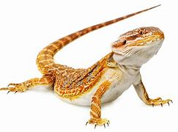 | Research all the considerations and make notes on each one.  Produce a fact sheet on owning a bearded dragon for the first time.
Consider the following:  - Owner preferences  - Responsibilities of pet ownership  - Health and safety (pet and owner)  - Cost of maintaining  - Exercise  - Accommodation | - Health care  - Identification  - Training  - Holiday arrangements  - Time looking after the pet

Case Study 2 | Task
A family wants a small companion pet for their daughter. They want to find out about owning hamsters for the first time.  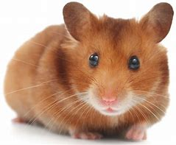 | Research all the considerations and make notes on each one.  Produce a fact sheet on owning a hamster for the first time.
Consider the following:  - Owner preferences  - Responsibilities of pet ownership  - Health and safety (pet and owner)  - Cost of maintaining  - Exercise  - Accommodation | - Health care  - Identification  - Training  - Holiday arrangements  - Time looking after the pet

Research activity tasks
Task 1
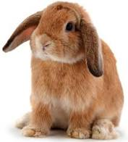
Research activity – Owning a rabbit.
Find out the answers to these questions.
Once complete, create an animal care guide or fact file
to be used at a pet store to help new owners learn
how to care for their new pet.

Questions

- How long might a rabbit live?
- When do rabbits eat?
- Why should rabbits not have Muesli?
- Name one type of predator for a rabbit
- Would you say a rabbit likes to have company? How do you know?
- Why could too many carrots be a danger to a rabbit?
- Name 2 things that would stop a rabbit getting bored
- How might a rabbit be feeling if it is sitting in a crouched position with its head flat to the ground?
- How should people treat a rabbit?

Task 2
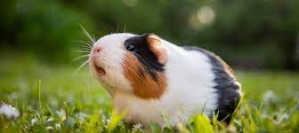
Research activity – Owning a Guinea Pig
Find out the answers to these questions.
Once complete, create an animal care guide or fact file
to be used at a pet store to help new owners learn
how to care for their new pet.

Questions

- Where do guinea pigs come from?
- What do guinea pigs need to eat
- What sort of hutch do guinea pigs need to live in and why?
- What could happen if a guinea pig gets too warm
- Give one example of something guinea pigs like to do
- What part of them grows all the time?
- What do guinea pigs do when they are scared?
- Name one thing a guinea pig might do if they are stressed
- What can make guinea pigs upset?
- Describe what sort of bedding a guinea pig needs

