Y11 Work Experience Virtual sessions
Due to Y11 missing their work experience last year we have the following work experience lessons available for your tutor group to complete. These sessions can be done during DEAR time or Form time as part of PSHE.
You may decide to watch some generic sessions together – please see schedule below for compulsory modules.
I would not advise that you watch all sessions as a whole form as some will not be of interest to all students.
For optional modules you will need to use a computer room/ book ipads and students will need to bring in their own headphones to listen to the clips.
To access the clips please follow the link below:
https://classroom.thenational.academy/year-groups/year-10/work-experience

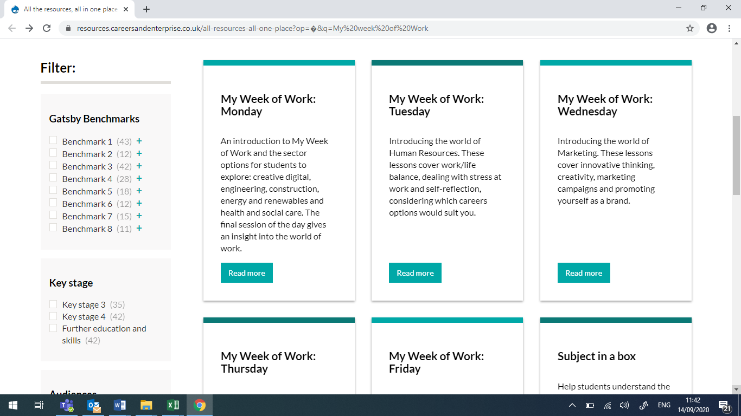
This is the home page. You will see each day across the top. There is no need to complete all of the sessions. Please see the list below with recommended compulsory sessions and then optional ones depending on your career interests. The sessions vary in length.
**Students will need to complete video tasks in their PSHE books. Please ensure they date the piece of work and label the title of the module.

Monday | Title | Video Time | Compulsory/ Optional | Information/Career
Lesson 1 | Introduction | 10 mins | Compulsory | Introduction to programme
Lesson 2 | Go explore 1 | 30 mins | Optional | Creative digital, Engineering, Construction
Lesson 3 | Go explore 2 | 15 mins | Optional | Health and Social, Renewables
Lesson 4 | Insight into world of work | 5 mins | Compulsory | Predictions in world of work

Tuesday | Title | Video Time | Compulsory/ Optional | Information/Career
Lesson 1 | Meet the team | 13 mins | Optional | Jobs in Human resources
Lesson 2 | Work life balance | 7 mins | Compulsory | Discuss stress and work life balance
Lesson 3 | Mental Health and well-being | 20 mins | Optional | Coping with stress at work
Lesson 4 | Self awareness and reflection | 10 mins | Compulsory | What career options would suit you?

Wednesday | Title | Video Time | Compulsory/ Optional | Information/Career
Lesson 1 | Meet the team | 15 mins | Optional | Jobs in Marketing
Lesson 2 | Innovation and creative thinking | 5 mins | Compulsory | Innovative thinking and continuous improvement
Lesson 3 | Marketing campaigns | 20 mins | Optional | Understand an effective marketing campaign
Lesson 4 | You as a brand | 10 mins | Compulsory | How to promote yourself

Thursday | Title | Video Time | Compulsory/ Optional | Information/Career
Lesson 1 | Recruitment | 15 mins | Compulsory | Skills employers look for
Lesson 2 | HR: Recruitment | 15 mins | Optional | How businesses recruit
Lesson 3 | Understanding Entrepreneurs | 10 mins | Optional | Qualities of enterprising individuals
Lesson 4 | Project planning skills | 5 mins | Optional | Skills needed to plan projects

Friday | Title | Video Time | Compulsory/ Optional | Information/Career
Lesson 1 | Meet the boss: Leadership | 15 mins | Compulsory | What makes an effective leader
Lesson 2 | CV creation | 7 mins | Compulsory | Key features of a CV
Lesson 3 | Employability skills in life | 10 mins | Optional | How to demonstrate employability skills
Lesson 4 | Reflection of the week | 9 mins | Compulsory | What to do next and seeing a careers advisor

