Key Stage 3 LMI Teacher Guide
Lesson aims and objectives:
- To raise awareness of the different sectors for employment
- To raise awareness of the roles available in the various sectors
- To understand the different pathways to enter the sector and the different roles
- To understand the skills and qualities needed for the different roles and the links to skills and qualities being developed in school.

Overview and suggested lesson:
Each week focusses on a different sector.
For each sector, you will find an overview page as shown below through the link on the LMI programme document:
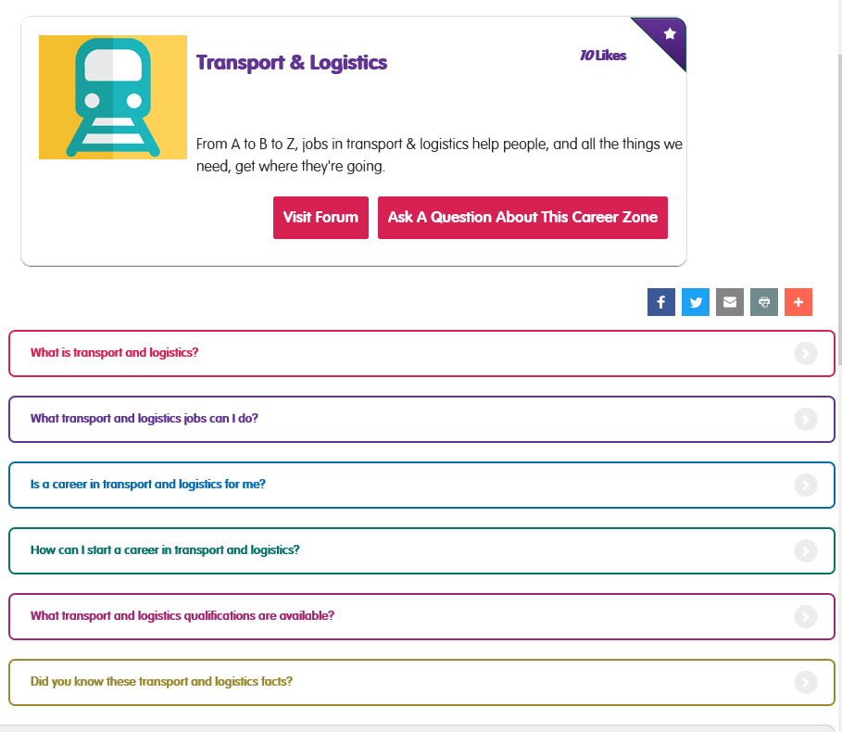
With your class you will need to read each of the sections, you could:
- Split the class into groups, ask them to read their given section and report to the group.
- Ask volunteers to read the sections aloud.
- Pair students to read sections to each other
Use the activity sheet document to encourage the students to record their findings for reference and to show understanding and knowledge gained.

Each sector also has interviews with people in the profession and/or information videos about qualifications and training. After watching the videos use questions like the ones below to stimulate conversation and debate:
- What is…… (insert sector name)?
- What jobs can you do in….?
- What skills and qualities do you need to work in…?
- How can you start a career in…?
- What qualifications are available in…?
- What interesting facts can you remember about…?

Reflection:
At the end of the series of lessons encourage students to think about the knowledge they have gained and reflect on what they now know and how this will impact future decisions.
Example discussion around:
- Which sectors have they learnt the most new facts about?
- Are there any sectors that they wouldn’t have thought about working in before which now appeal to them?
- How many of their parents/ families work in the sectors – what do they now think about their roles?
- Did you know about all the different pathways before these lessons?

