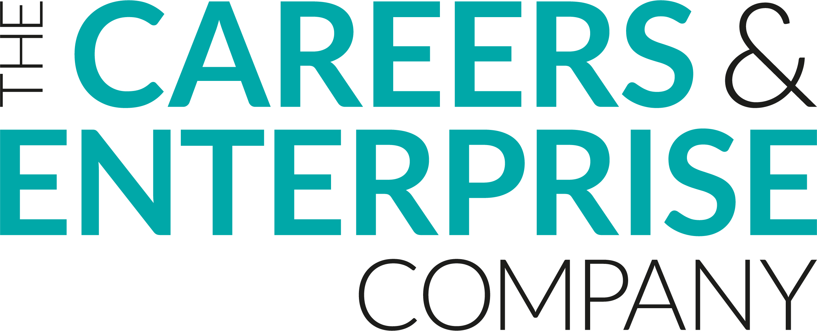
Careers Programme Evaluation
Employer
Name:
Organisation:

Preparation & Intent
I understand the vision and focus areas for careers provision in the school/college
Strongly agree | Agree | Neither Agree nor Disagree | Disagree | Strongly Disagree
I understand the programme and key elements of the careers programme at this school/college
Strongly agree | Agree | Neither Agree nor Disagree | Disagree | Strongly Disagree
The programme is well planned to support students to develop key employability skills
Strongly agree | Agree | Neither Agree nor Disagree | Disagree | Strongly Disagree
The programme is well planned to help students to understand careers and the world of work
Strongly agree | Agree | Neither Agree nor Disagree | Disagree | Strongly Disagree
The programme has clear links to school/college priorities
Strongly agree | Agree | Neither Agree nor Disagree | Disagree | Strongly Disagree
Organisation and Implementation
The school/college helps students and parents/carers to access labour market information about jobs and opportunities locally and nationally
Strongly agree | Agree | Neither Agree nor Disagree | Disagree | Strongly Disagree
The school/college helps students and parents/carers to access information on a range of career pathways and all options at key decision points (GCSOE Options, Post 16, Post 18,etc.)
Strongly agree | Agree | Neither Agree nor Disagree | Disagree | Strongly Disagree
Students are well supported to make informed decisions at key decision points
Strongly agree | Agree | Neither Agree nor Disagree | Disagree | Strongly Disagree
Impact
Student progress against the career programme’s learning outcomes is clear
Strongly agree | Agree | Neither Agree nor Disagree | Disagree | Strongly Disagree
Student progress in developing key employability skills is clear
Strongly agree | Agree | Neither Agree nor Disagree | Disagree | Strongly Disagree
There is evidence of impact from the career programme in destination data and other key student outcome measures
Strongly agree | Agree | Neither Agree nor Disagree | Disagree | Strongly Disagree
What works well about the careers programme?
How could the careers programme be even better?
Thank you for completing this form, we really value your feedback in continuing to develop our careers provision. For further information, please visit: WEBSITE and/or contact: CAREERS LEADER EMAIL

