HOTSW Careers Hub Mentoring Programme

Contents:

 | Overview | Page 2
Session 1 | About Me | Page 3
Session 2 | Identifying strengths | Page 4
Session 3 | What Employers Want | Page 5
Session 4 | Communication Skills | Page 6
Session 5 | Life Finance | Page 7
Session 6 | Teamwork | Page 8
Session 7 | Professionalism | Page 9
Session 8 | Tolerance & Diversity | Page 10
Session 9 | Recruitment Techniques | Page 11
Session 10 | What’s the point? | Page 12
 | Evaluation | Page 13
 | Appendices | Page 14

Overview
The HOTSW careers hub mentoring programme is designed to be delivered by Enterprise Advisers within their respective schools. It can also be delivered by members of school staff / governors or other volunteers from the business world.

The programme has two main objectives:

Raising Aspiration – broadening a students’ horizons, rather than narrowing their options in terms of goals, careers, and self-awareness.

Personal Development – developing a students’ skills, knowledge and personal attributes in line with the requirement of today’s world of work.

The programme will run over 10 sessions where the Enterprise Adviser will work with a small group of students from year 10 – once per half term (or equivalent) up to Easter in Year 11.

It is envisaged that 4-6 students will be selected by the school – identifying those who lack confidence in their own ability and who with a small amount of encouragement could achieve higher grades, improve motivation, attendance and participation.

Each session will last 30-40 minutes

Suggested activities are provided for each session. You can use one, both or something else entirely.

This programme is a guide only and can be adapted to suit the needs of the mentor / mentees / school.

SESSION 1 – About me

Aim:

To introduce students to Enterprise Adviser and to begin to build relationships and trust within the group.

The Enterprise Adviser will introduce themselves and explain a little about their background including schooling, career history, how they got into the job they are doing now etc.

Enterprise Adviser will set boundaries for all meetings going forward e.g.:

- Full participation / Commitment
- Trust
- Respect one another
- Ask students if they have any rules they would like included

Suggested activity

This is me….
Resources required: This is me questionnaire – See Appendix 1 Give the students time to complete the questionnaire.
Talk through the answers on the individual student’s questionnaires.

SESSION 2 – Identifying Strengths

Aim:
To identify students’ strengths and what careers pathways they can suit. Also, to identify potential weaknesses and work on a strategy to improve them.

Understanding your own strengths and potential weaknesses is crucial. Even the most talented, respected people have weaknesses or areas in which they don’t excel. Play to your strengths and work on your weaknesses.

Suggested activities

Buzz Test
Resources required – laptop https://icould.com/buzz-embed/
Students take the buzz test which shows their strengths and the type of roles these are best suited to.

Strengths Matrix
Resources required – Strengths grid - see Appendix 2

Students look at Strengths matrix and tick all of the boxes that are relevant to them. Ask them to add in another row of things that they are good at.
Now focus on weaknesses – giving examples of some of your own. Look at the strength grids – are some of the unticked boxes weaknesses?

Write weaknesses on the back of the page and discuss how they can be worked on.

SESSION 3 - What Employers Want

Aim:

To identify key skills and attributes employers are looking for.

Employers are all looking for the same sorts of things. They can teach someone the technical side of a job – it is the personal attributes that they can’t teach.

Suggested activity

Identifying skills employers are looking for
Resources required – flipchart / paper

List and discuss the skills and attributes that an employer would be looking for. E.g.:

Good communication skills Good Work Ethic
Honesty Integrity
Reliability Good Time Keeping
Respectful Good listening skills
Organised Responsible
Motivated Teamwork
Flexibility Determination
Can do approach Problem Solving Put them in order of importance.
Remember – an employer can teach you to make a cappuccino - they can’t teach you
to smile, make eye contact, be happy and make the customer experience a good one!

SESSION 4 – Communication

Aim:
To understand various ways of communicating and importance of good communication skills within all aspects of life.

Good communication is key not just in the world of work but in life in general. Poor communication lies at the root of many problems and can lead to mistakes, poor quality, missed deadlines and sometimes conflict. How we communicate with others is so important.

Discuss verbal and non-verbal communication including body language, tone of voice etc.

Suggested activities

Interpreting Body Language
See Appendix 3 or contact Nicky Henderson for Powerpoint of facial expressions which can be discussed as a group.

Blindfold Game
Resources required: Blindfold & small prize

Putting students in pairs, blindfold one and get the other to talk them across the room to collect a small prize.

Repeat until all students have undertaken both the blind fold and the navigator role.

Check with students how they felt when they were blindfolded and how they received the instructions from their partner. Then ask the same regarding being the person giving the instructions.

SESSION 5 – Life Finance

Aim:

To understand monthly budgeting and managing bank accounts in addition to looking at real life cost of living.

Whether you are buying your first car, setting up home or going on holiday with your mates – being able to budget properly is a vital life skill.

Suggested activities

Barclays Lifeskills Budget Game
Required resources – Barclays Lifeskills Budget game printed board, cards and budget planner – register on https://barclayslifeskills.com/sign-in/educator/ for free copies; or contact nicky.henderson@devon.gov.uk

Students play Barclays Budget Game together as one team – budgeting for one month.

My Moneysense quiz
Resource required - laptop https://mymoneysense.com/challenge/credit-or-debt/
To improve teamwork skills and appreciate one another’s strengths and weaknesses.
Aim:
SESSION 6 – Teamwork

Being able to work as part of a team is a skill many employers look for. They want someone who will work well with others, appreciate everyone else’s contribution and not get on other people’s nerves!

Everyone has something offer – even if it isn’t immediately that obvious.

Suggested activities

Lost Disaster Scenario
Resources required: Lost Disaster information – see Appendix 4

Allow students to establish which of the passengers should be allowed on the lifeboat. Discuss their reasons

Cup Stack
Resources required: paper cups, rubber band, string – see Appendix 5

To understand acceptable behaviour within the work place.
SESSION 7 - Professionalism
Aim:

How you behave at home is often very different to what is expected of you at work. You wouldn’t put your feet up on the desk at work, but you might put your feet up on the coffee table at home when you are watching the TV. However, some things remain the same regardless – like attitude, the way you speak to people and respecting others.

Suggested activities

Acceptable/Unacceptable behaviour
Resources required: Acceptable / Unacceptable behavior template – see Appendix 6

Discuss responses and give some personal examples of poor behavior you have witnessed.

Professional behaviour at work video
Resources required: Laptop https://www.youtube.com/watch?v=14bCsM16bYo
Watch the video and discuss.

SESSION 8 – Tolerance & Diversity

Aim:
Appreciation of what makes us all different and the benefits of diversity within a team.
We live in a society with all sorts of other people. We are all unique, but we all have feelings and get hurt when others single us out. Being tolerant of others and understanding how what we say or how we act can make them feel, is really important.

Suggested Activities

How Comfortable am I? Quiz
Resources required – How Comfortable am I quiz sheets – see Appendix 7 Students complete the How Comfortable am I? quiz
Go through and discuss answers.

Then highlight the different personality types and what they can bring to a team set up.

Take the Life in the UK test
Resources required – Laptop https://lifeintheuktestweb.co.uk/
See what people from outside the UK have to do before they are allowed to stay.

Inclusion starts with I
Resource required – Laptop

Watch the “Inclusion starts with I” video and discuss https://www.youtube.com/watch?v=2g88Ju6nkcg

SESSION 9 - Recruitment Techniques

Aim:

Understanding the different methods employers use to recruit.
There are a number of different ways employers recruit. Some have multiple stages, others just want a quick 5 minute chat. Understanding the different recruitment techniques can help you to understand what to expect when you go for a job.

Suggested Activities

Identify some of the current recruitment techniques e.g.:

Online application Assessment Centre
CV Telephone Interview
Panel interview Skype Interview
Online test Work Trial

Panel Interview
Resources needed – job description, paper & pens

Pick a job off the National Apprenticeship website and ask the students to be the interviewers. They will need to develop the questions between them then they can interview the Enterprise Adviser for that job

Spaghetti & Marshmallow Bridge construction
Resources needed – dried spaghetti, marshmallows

Run the spaghetti and marshmallow challenge used at Asda group assessment days.

Ask the group to build the highest structure they can in 15 minutes using the spaghetti & marshmallows

Observe the group dynamic and feedback at the end.

SESSION 10 – What’s the point?

Aim:

Identifying the relevance of what we learn in school within the world of work.
All things in school are taught for a reason – although it may not seem like it at times! Understanding why you are learning something by cross referencing it to the real world can make it much more interesting.

Suggested activities

Linking careers with lessons taught in school
Resources required: Cards – see Appendix 8
Student template – see Appendix 8b

Create cut-off cards with the different subjects learned at school – Appendix 8, then shuffle and distribute between the students.
On the Template – Appendix 8b the students write down jobs or careers where they think each given subject would lead or contribute to.

Discuss each student’s favourite subject and discuss which roles that subject can lead to.

What’s the point of school rules?

Talk to students about rules within school such as timekeeping, uniform, acceptable behaviour etc and cross reference to the work environment.
EVALUATION

It is good practice to evaluate the effectiveness of any programme.

As the overall aim of the mentoring programme is to raise aspirations, attainment and confidence of students it is good to understand where the students’ starting points are.

Discuss each student with the school careers lead and ensure that you plan in regular catch ups to discuss the progress of each student throughout the programme.

Monitor their attendance, attitude and behavior throughout, and work with the careers lead to see if the mentoring makes a difference to their attainment.

It is also good to capture the thoughts of the students too – has this made a difference to them?

You can decide with the careers lead just how you do this – some example evaluations can be found in Appendix 9 but the school may have something that they prefer you use.

APPENDICES

Appendix | Document | Page
1 | This is me | Page 15
2 | Strengths matrix | Page 16
3 | Interpreting Body Language | Page 17
4 | Lost Disaster | Page 18
5 | Cup Stack Challenge | Page 32
6 | Acceptable/Unacceptable behaviour | Page 33
7 | How Comfortable am I? | Page 34
8 | What’s the point template | Page 35
8b | What’s the point cards | Page 36
9 | Evaluations

APPENDIX 1 This is me……………………………..

My name is

My favourite things to do are I think I am good at
My favourite place I have ever been to is The thing I am most proud of having done is My favourite thing in my room or house is
I have always wanted to

I would like to get better at

These are the words friends would use to describe me If I could change one thing about the world it would be

APPENDIX 2 STRENGTHS MATRIX

Name …………………………………………………………..

Is good at maths | Works hard | Likes to join in | Is organised | Is good with computers
Is a daredevil | Plays a team sport | Is good at spelling | Tells good jokes | Likes to read
Plays a musical instrument | Has a good memory | Likes to think thing through | Is good at making things | Is good at cooking
Likes to go out with friends | Likes to help others | Is good at art | Is a loyal friend | Is tidy
Is willing to learn new things | Likes to figure out how things work | Likes animals | Is always on time | Likes being on their own

Add in another row of strengths at the bottom
APPENDIX 3 BODY LANGUAGE

Discuss the power of body language and how without saying a word you can say so much!

Use some of the poses below and ask students how they interpret them

Pose | Possible Interpretation
Standing with hands on hips | Aggression, Disgust
Stand upright and tall | Confidence
Fold arms across chest | Defensive
Rolling your eyes | Dismissive / Irritated
Resting head in hands | Bored
Tapping fingers | Impatient
Weak handshake | Nerves
Rubbing temple | Doubt / Unsure
Biting nails | Nervous / Insecure
Slouching in seat | Disinterested
Stroking chin | Thinking / Contemplating
Looking down | Lack of confidence
Tilted head to one side | Listening / Interested
Pinch bridge of nose | Thinking / Unsure
Shrug | Disinterest

APPENDIX 4 LOST!

You are all the occupants of a sinking ship.

A fire on board has destroyed the radio and, from the rate the water is rising inside the ship, you estimate that it will sink in between two hours and two and a half hours.

You did not tell the authorities of your destination.

It will take about 45 minutes to launch the only boat and it will take 15 minutes for each person to be lowered into the boat, they can only go one at a time.

They can't jump as the water is shark infested.

The nearest land is an uninhabited tropical island 30 km distant.

Your task is to decide as a group which passengers will enter the boat. Everyone on-board has agreed to abide by your decision.
Items held by individuals must stay with the owner; they cannot be transferred to other people.

Billy: Lives in a village in Sussex.
His parents are: Nigel and Sarah. Nigel is a Bank Manager and Sarah is a Home Maker. In Sarah’s spare time she is a Guide leader,
Nigel is a Parish councillor and president of the local allotment society in spare time.
Billy has £50,000 in used £10 notes and a box of matches

Natalia: age 23.

Came to Scotland eight years ago as a teenage refugee from Ukraine and spoke no English on arrival.
Gained 6 GCSEs and has recently qualified as a nurse.
Carries a box of matches.

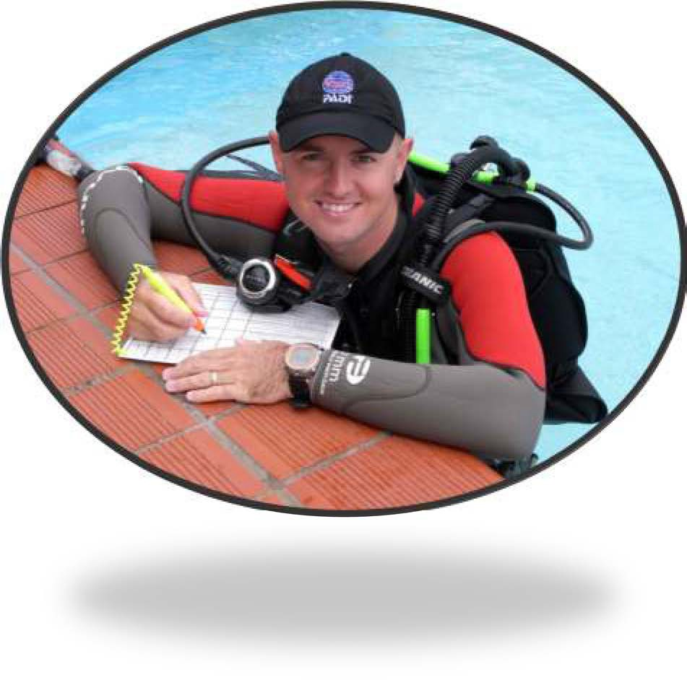
Tom: Diving Instructor. After 20 years as a stockbroker in London, he has just moved to Tahiti to set up his own diving school.
Divorced, with a son at boarding school in Wales. Goes grouse-shooting in Yorkshire every August. Carries a signed copy of the final Harry Potter novel.

David – Food Scientist. A vegetarian whose research centres on developing plant-based, low-cholesterol alternatives to meat.
He has been involved in a number of demonstrations against the use of animals in medical research.
Carries a box of Mars bars.

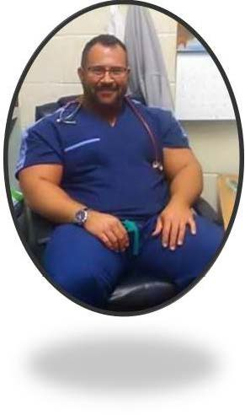
Adam - Nurse.
Married three times; five children aged between 5 and 27. Youngest child has Down's syndrome.
Drinks and smokes heavily. Plays the accordion.
Carries a bottle of rum.

Annie - Ship's engineer's wife: Aged 35 and about to begin maternity leave from her work as a medical sales representative.
Due to give birth to their first child in 4 months time.
For some reason known only to herself she happens to be carrying a fishing line and hook.

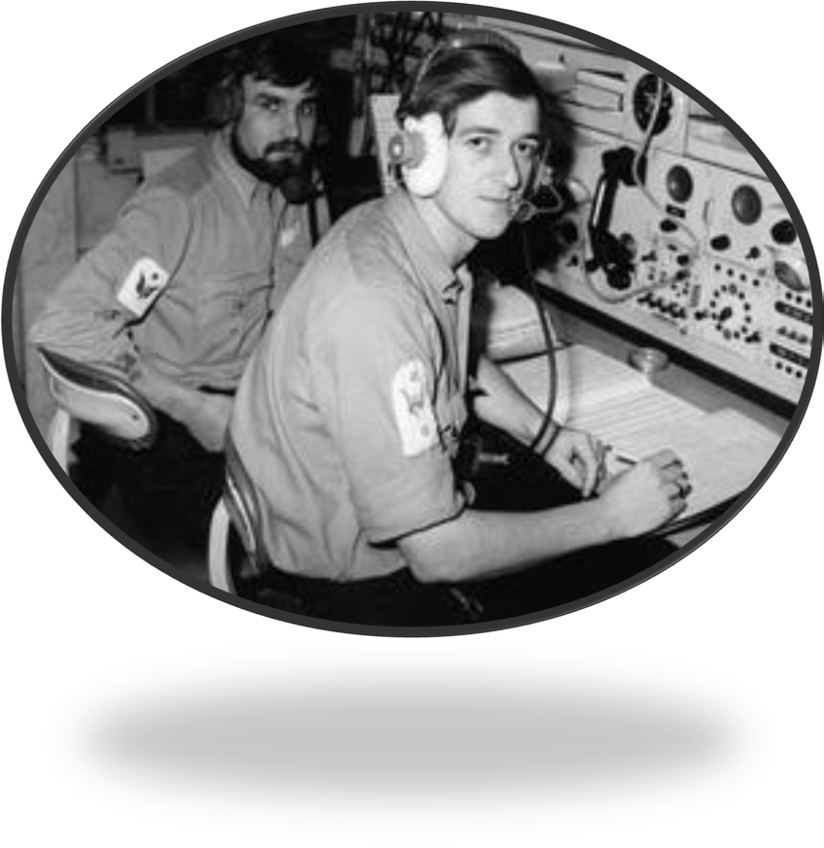

Stefan - Radio operator: ex-Israeli Navy. A fitness fanatic and champion kick boxer.
He escaped the fire which destroyed his radio as he was on deck trying to impress the food scientist with a display of his kickboxing skills at the time. Carries a length of rope.

Nigel - Retired soldier. Recently registered a civil partnership with his long-term partner, a 45-year old political journalist.
Together, they have campaigned for improved healthcare for soldiers wounded in Iraq.
Carries a compass.

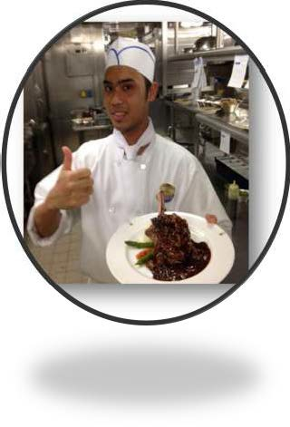
Chaps - Cook: a former Special Forces officer reduced to working as a cook after being court-martialled following an unfortunate incident involving a torpedo and a presidential yacht.
Carries a knife

Trevor - Anglican priest: a Philosophy graduate who taught English as a foreign language in South America for several years before returning to his home town to look after his disabled mother (now aged 85) with whom she still lives.
Trained as a counsellor and was ordained in 1990. Carries a first aid kit

Lizabet - French Botany student: Lived in the Brazilian rainforest for eighteen months while carrying out Ph.D. research into plants that can be used in anti-cancer drugs: these are now undergoing testing by a major multinational pharmaceutical company.
Voted for Le Pen in the last election. Has a rifle.

Rupi - Indian ship's carpenter: Married with four children aged between six months and seven years old.
Was convicted of violent affray following a demonstration in Mumbai ten years ago.
Writes poetry and has had two poems published in Indian literary magazines.
Has a magnifying glass

Scarlet - Ship's engineer: married; accompanied by her pregnant wife. Her heroism in fighting the fire has given her fellow-passengers time to launch the lifeboat but she has sustained severe burns.
Carries a mirror.
APPENDIX 5 CUP STACK CHALLENGE

Resources required: paper cups, rubber band, string

The challenge is for the group to build a pyramid out of the paper cups (3 on the bottom, 2 in the middle, 1 on the top. Group members cannot touch the cups with their hands or any other part of their bodies, even if a cup falls over or on the floor.

Each person holds onto one of the strings that are attached to the rubber band and they use this device to pick up the cups and place them on top of each other (by pulling the rubber band apart and then bringing it back together over the cups).

After you have finished, discuss the following:

- Was anyone frustrated at all during the activity?
- What did you learn about yourself or others?
- Why was teamwork so important for this activity?
- What is so hard about teamwork?
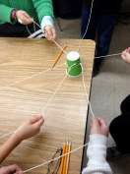
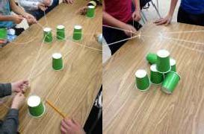
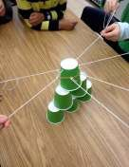
APPENDIX 6 ACCEPTABLE / UNACCEPTABLE BEHAVIOUR AT WORK

Expected behaviour | Unacceptable behaviour (opposite?)
Hard working
Reliable
Good timekeeper
Ready to start work on time (e.g. proper gear on, had your breakfast!)
Correctly dressed and presented for the job in hand
Pleasant and polite to co-workers and customers
Follow supervisor’s instructions
Keen to learn new things
Learn from mistakes (we all make them!)
Get on with everyone
Good team player
Work safely
Aware of dangers/hazards in the workplace
Don’t waste anything (e.g. paper, wood, electricity)
Ask for help when need it

APPENDIX 7 - HOW COMFORTABLE AM I?

 | Not at all comfortable | Uneasy | Fairly comfortable | Totally comfortable
You visit your Grandma in a care home
A friend tells you they are gay
A homeless person asks you for change
Your history teacher speaks with a German accent
A classmate is in a wheelchair
Your maths teacher is a 60 year old woman
Your next door neighbour is Muslim
A friend invites you to go to church
You see someone who is transgender
A new classmate is a refugee from Somalia
A friend’s Dad has been in prison
A classmate has a stutter
A woman in your street is 25 stone
Your best male friend takes up ballet
You have to sit next to the “uncoolest” kid in class

Page | 35

APPENDIX 8 WHAT’S THE POINT?

What’s the Point?
Student Name:
Favourite Subject(s):
Preferred Job/Career:
Reasons for favourite subject & preferred job/career:
Subject (Card reference) | Related jobs / professions (student input)
1-
2-
3-
4-
Action(s) or thoughts gained from the exercise:

Page | 36

APPENDIX 8b – CARD TEMPLATES & EXAMPLE POSTERS

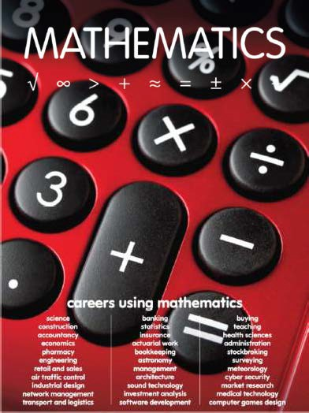

These posters can be obtained free from:

https://www.planitplus.net/Schools/SubjectCareerPosters/

APPENDIX 9 EVALUATION

Please answer the following questions scoring from 1-5 (low to high)

Have you enjoyed your sessions?

1 | 2 | 3 | 4 | 5

How nervous were you about undertaking these sessions?

1 | 2 | 3 | 4 | 5

Do you think that the sessions have helped you build confidence?

1 | 2 | 3 | 4 | 5

How good is your understanding of what employers are looking for?

1 | 2 | 3 | 4 | 5

Would you recommend mentoring sessions to others?

1 | 2 | 3 | 4 | 5

Any other comments or requests for the future?

Thank you!

