Careers Education, Information, Advice and Guidance Policy

Contents

1.0 School Vision

2.0 Policy Scope

3.0 Objectives

4.0 School Responsibilities

5.0 Governor Responsibilities

6.0 Provider Access

7.0 Monitoring, Evaluation and Review

Appendix 1 Summary of the Gatsby Benchmarks
Appendix 2 Careers Charter
Appendix 3 Arrangements for Provider Access

Linked policies

Linked Documents

‘Careers Guidance and access for education and training providers. Statutory guidance for governing bodies, school leaders and school staff’. DFE, January 2018

Adopted by the Governing Body: March 2018
Compliance Check: March 2020
Review Period: 3 Years
Review Date: Cycle 4 (Spring) 2021

Careers Education, Information, Advice and Guidance Policy

1.0 School Vision

1.1 XXXXXXXXXXXX seeks to maximise the life chances of all of our young people and so it is crucial to prepare young people for life beyond school and college. The values and principals document makes direct reference to developing:

‘knowledge, skills and attributes they (XXXXXXXXXX students) need to lead successful and happy lives’

1.2 The governing body have therefore adopted this policy in order to provide a clear commitment to and framework for Careers Education, Information, Advice and Guidance

2.0 Policy Scope

2.1 This policy covers Careers Education, Information, Advice and Guidance given to students in Key Stages Three and Four.

2.2 The policy also applies to Year 11 students after they finish their examinations in June of their final year and before they start at their next place of education, employment or training. Though not necessarily in school regularly and attending lessons in July and august of Year 11, the policy is still applicable.

2.3 The policy has been reviewed in line with the recently published DfE guidance document ‘Careers guidance and access for education and training providers – Statutory guidance for governing bodies, school leaders and school staff. (DfE, January 2018)

2.4 This policy accepts the 8 Gatsby Charitable Foundation’s benchmarks as set out in the DfE guidance. They can be seen in Appendix 1of this policy

2.5 This policy covers the legal duty of schools to ensure that a range of education and training providers can access pupils in Year 7 to Year 11 for the purpose of informing them about approved technical education qualifications or apprenticeships.

2.6 This policy refers to events and opportunities in both Key Stages and in all years and these events will impact upon all students at the school.

2.7 All members of staff at xxxxxxxxxxxxxxxx are expected to be aware of this policy and the importance of Careers Education, Information, Advice and Guidance (CEIAG) in the education of students; CEIAG is not the sole responsibility of the Careers Advisor.

2.8 It is important therefore that students leave school aware of themselves as individuals, aware of the opportunities available to them and able to make some decisions about their own life. They should be prepared for the transition from full time education to the world beyond. It is to these aspects of personal and social development that this policy will contribute.

3.0 Objectives:

3.1 The objectives of the Careers Education, Information, Advice and Guidance policy are as follows:

3.1.1 To ensure that all students at the school receive a stable careers programme
3.1.2 To enable all students to learn from information provided by the career and labour market
3.1.3 The CEIAG programme should be individual and address the needs of each student
3.1.4 To link the curriculum learning to careers learning
3.1.5 To provide students with a series of encounters with employers and employees
3.1.6 To provide students with experiences of workplace(s)
3.1.7 To ensure that students have a series of encounters with further and higher education
3.1.8 To provide each student with the opportunity to receive personal guidance

4.0 School Responsibilities

4.1 The school has a series of statutory duties:

4.1.1 All registered pupils at the school must receive independent careers advice in Years 7 to 11

4.1.2 This careers advice must be represented in an impartial manner, showing no bias towards a particular institution, education or work option

4.1.3 This advice must cover a range of education or training options

4.1.4 This guidance must be in the best interests of the pupil

4.1.5 There must be an opportunity for education and training providers to access pupils in Year 7 – Year 11 in order to inform them about approved technical qualifications or apprenticeships. Cf. Section 6 of this policy

4.1.6 The school must have a clear policy setting out the manner in which providers will be given access to pupils. Cf. Section 6 and Appendix 3. This policy and these arrangements must be published

4.2 The school will base its careers provision around the Gatsby Benchmarks. A summary of these can be seen in Appendix 1, and they cross reference with the objectives of this policy cf. Section 3

4.3 xxxxxxxxxxxxxxx believes that good CEIAG connects learning to the future. It motivates young people by giving them a clearer idea of the routes to jobs and careers that they will find engaging and rewarding. Good CEIAG widens pupils’ horizons, challenges stereotypes and raises aspirations. It provides pupils with the knowledge and skills necessary to make successful transitions to the next stage of their life. This supports social mobility by improving opportunities for all young people, especially those from disadvantaged backgrounds and those with special educational needs and disabilities.

4.4 The school will continuously monitor its CEIAG offer and seek further improvement. This will be done by the personnel involved in the design and delivery of the programme as well as by external stakeholders who assess the work of the school (eg. School Improvement Partner or Ofsted)

5.0 Governor Responsibilities

5.1 The governing body will ensure that the School has a clear policy on Careers Education, Information and Guidance (CEIAG) and that this is clearly communicated to all stakeholders. They should ensure that this policy is:

5.1.1 based on the eight Gatsby Benchmarks

5.1.2 meeting the school’s legal requirements

5.2 The governing body will ensure that arrangements are in place to allow a range of educational and training providers to access pupils in Years 7 – 11.

5.3 There will be a member of the governing body who takes a strategic interest in CEIAG and encourages employer engagement

6.0 Provider Access

6.1 Introduction - This section of the policy sets out the school’s arrangements for managing the access of providers to pupils at the school for the purpose of giving them information about the provider’s education or training offer. This complies with the school’s legal obligations under Section 42B of the Education Act 1997.

6.2 All pupils in years 7-13 are entitled:

6.2.1 to find out about technical education qualifications and apprenticeships opportunities, as part of a careers programme which provides information on the full range of education and training options available at each transition point;
6.2.2 to hear from a range of local providers about the opportunities they offer, including technical education and apprenticeships – through options events, assemblies and group discussions and taster events;
6.2.3 to understand how to make applications for the full range of academic and technical courses.

6.3 Appendix 3 shows the way in which education and training providers should get in touch with the school in order to gain access to pupils and/or parents to inform them about further opportunities

6.4 The school will then work with providers in order to identify the most effective opportunity for them to share information about education and training opportunities

7.0 Monitoring, Evaluation and Review

7.1 The Headteacher will ensure that:

7.1.1 the work of the Careers Advisor and CEIAG events are supported and monitored

7.1.2 a member of the Senior Leadership Team has an overview of CEIAG work and reports regularly back to the team

7.2 The effectiveness of this policy will be measured in a variety of ways:

7.2.1 Feedback from stakeholders through mechanisms such as the Kirkland Rowell student and parent survey;

7.2.2 Feedback from external visitors to the school such as the School Improvement Partner (SIP) or Ofsted;

7.2.2 the number of students who are NEET in October having left the school in the previous summer. This figure can be compared to national figures as well as against the equivalent figure from similar schools both nationally and within the county.

7.3 The governors of xxxxxxxxxxxxxx will review this policy every three years.

The Gatsby Benchmarks Appendix 1

1. A stable careers programme | Every school and college should have an embedded programme of career education and guidance that is known and understood by students, parents, teachers, governors and employers. | • Every school should have a stable, structured careers programme that has the explicit backing of the senior management team, and has an identified and appropriately trained person responsible for it.  • The careers programme should be published on the school’s website in a way that enables pupils, parents, teachers and employers to access and understand it.  • The programme should be regularly evaluated with feedback from pupils, parents, teachers and employers as part of the evaluation process.
2.Learning from career and labour market information | Every student, and their parents, should have access to good quality information about future study options and labour market opportunities. They will need the support of an informed adviser to make best use of available information. | • By the age of 14, all pupils should have accessed and used information about career paths and the labour market to inform their own decisions on study options.  • Parents should be encouraged to access and use information about labour markets and future study options to inform their support to their children.
3.Addressing the needs of each student | Students have different career guidance needs at different stages. Opportunities for advice and support need to be tailored to the needs of each student. A school’s careers programme should embed equality and diversity considerations throughout. | • A school’s careers programme should actively seek to challenge stereotypical thinking and raise aspirations.  • Schools should keep systematic records of the individual advice given to each pupil, and subsequent agreed decisions.  • All pupils should have access to these records to support their career development.  • Schools should collect and maintain accurate data for each pupil on their education, training or employment destinations.
4.Linking curriculum learning to careers | All teachers should link curriculum learning with careers. STEM subject teachers should highlight the relevance of STEM subjects for a wide range of future career paths. | • By the age of 14, every pupil should have had the opportunity to learn how the different STEM subjects help people to gain entry to, and be more effective workers within, a wide range of careers.
5.Encounters with employers and employees | Every student should have multiple opportunities to learn from employers about work, employment and the skills that are valued in the workplace. This can be through a range of enrichment activities including visiting speakers, mentoring and enterprise schemes. | • Every year, from the age of 11, pupils should participate in at least one meaningful encounter* with an employer.  *A ‘meaningful encounter’ is one in which the student has an opportunity to learn about what work is like or what it takes to be successful in the workplace.
6.Experiences of workplaces | Every student should have first-hand experiences of the workplace through work visits, work shadowing and/or work experience to help their exploration of career opportunities, and expand their networks. | • By the age of 16, every pupil should have had at least one experience of a workplace, additional to any part-time jobs they may have.  • By the age of 18, every pupil should have had one further such experience, additional to any part-time jobs they may have.
7.Encounters with further and higher education | All students should understand the full range of learning opportunities that are available to them. This includes both academic and vocational routes and learning in schools, colleges, universities and in the workplace. | • By the age of 16, every pupil should have had a meaningful encounter* with providers of the full range of learning opportunities, including Sixth Forms, colleges, universities and apprenticeship providers. This should include the opportunity to meet both staff and pupils.  • By the age of 18, all pupils who are considering applying for university should have had at least two visits to universities to meet staff and pupils.  *A ‘meaningful encounter’ is one in which the student has an opportunity to explore what it is like to learn in that environment.
8.Personal guidance | Every student should have opportunities for guidance interviews with a career adviser, who could be internal (a member of school staff) or external, provided they are trained to an appropriate level. These should be available whenever significant study or career choices are being made. | • Every pupil should have at least one such interview by the age of 16, and the opportunity for a further interview by the age of 18.

xxxxxxxxxxxx Careers Charter Appendix 2

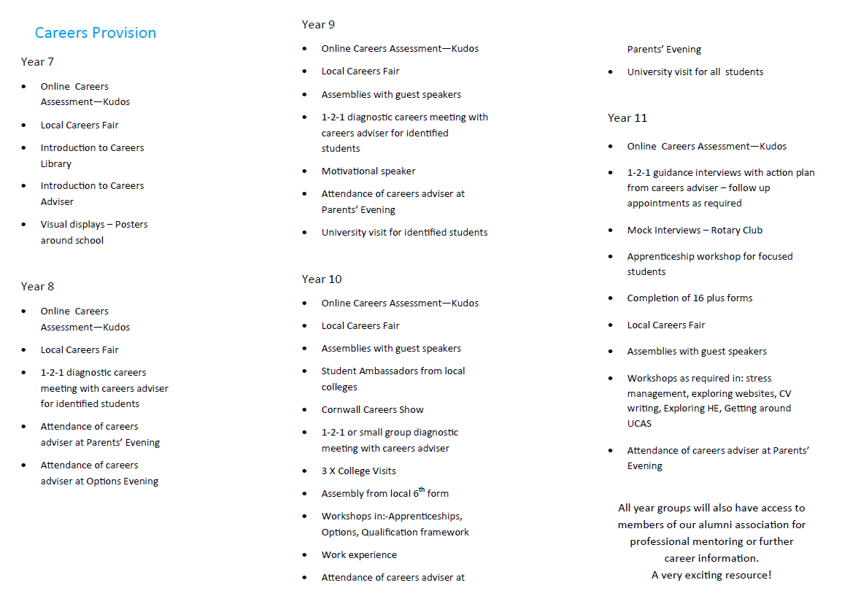

Application for Provider Access Appendix 3

Introduction

This document sets out the school’s arrangements for managing the access of providers to pupils at the school for the purpose of giving them information about the provider’s education or training offer. This complies with the school’s legal obligations under Section 42B of the Education Act 1997.

Pupil entitlement

All pupils in years 7-13 are entitled:

• to find out about technical education qualifications and apprenticeships opportunities, as part of a careers programme which provides information on the full range of education and training options available at each transition point;
• to hear from a range of local providers about the opportunities they offer, including technical education and apprenticeships – through options events, assemblies and group discussions and taster events;
• to understand how to make applications for the full range of academic and technical courses.

Management of provider access requests

Procedure

A provider wishing to request access should contact xxxxxxxxxxx.

Telephone:

Email:

Opportunities for access

The school offers a comprehensive Careers Education, Information, Advice and Guidance programme and an overview of this programme can be seen in the School’s Careers Charter which can be seen on the school website.

Please speak to our Careers Advisor to identify the most suitable opportunity for you.

The school will make a suitable space available for discussions between the provider and students, as appropriate to the activity. The school will also make available ICT and other specialist equipment to support provider presentations. This will all be discussed and agreed in advance of the visit with the Careers Advisor or a member of their team.

Providers are welcome to leave a copy of their prospectus or other relevant course literature with the Careers Advisor so that they can be displayed in the Careers Section of the school library.

